Mobile Application Development Lab Record

Name: Riya Ganesh Shanbhag
Registration No.: 230953058
Branch: Computer & Communication Engineering (CCE)
Batch: D1
Roll No.: 8

Lab 1: BASICS OF ANDROID MOBILE APPLICATION DEVELOPMENT TOOL

Q1: Create an Android application to show the demo of displaying text with justifying elements, changing text colors ,fonts etc.

MainActivity.java:
package com.example.demo;

import android.graphics.Color;
import android.graphics.Typeface;
import android.os.Bundle;
import android.view.View;
import android.widget.TextView;
import androidx.appcompat.app.AppCompatActivity;

public class MainActivity extends AppCompatActivity {

TextView textView;
float currentSize = 18f;

@Override
protected void onCreate(Bundle savedInstanceState) {
super.onCreate(savedInstanceState);
setContentView(R.layout.activity_main);

textView = findViewById(R.id.textView);
}

public void makeRed(View view) {
textView.setTextColor(Color.RED);
}

public void makeBlue(View view) {
textView.setTextColor(Color.BLUE);
}

public void makeBold(View view) {
textView.setTypeface(null, Typeface.BOLD);
}

public void makeItalic(View view) {
textView.setTypeface(null, Typeface.ITALIC);
}

public void increaseSize(View view) {
currentSize += 2;
textView.setTextSize(currentSize);
}
}

activity_main.xml:
<?xml version="1.0" encoding="utf-8"?>
<LinearLayout xmlns:android="http://schemas.android.com/apk/res/android"
android:layout_width="match_parent"
android:layout_height="match_parent"
android:orientation="vertical"
android:padding="16dp">

<TextView
android:id="@+id/textView"
android:layout_width="match_parent"
android:layout_height="wrap_content"
android:text="Demo Text"
android:textSize="18sp"
android:padding="8dp"
android:justificationMode="inter_word"/>

<Button
android:id="@+id/redBtn"
android:layout_width="match_parent"
android:layout_height="wrap_content"
android:text="Make Text Red"
android:onClick="makeRed"/>

<Button
android:id="@+id/blueBtn"
android:layout_width="match_parent"
android:layout_height="wrap_content"
android:text="Make Text Blue"
android:onClick="makeBlue"/>

<Button
android:id="@+id/boldBtn"
android:layout_width="match_parent"
android:layout_height="wrap_content"
android:text="Bold Text"
android:onClick="makeBold"/>

<Button
android:id="@+id/italicBtn"
android:layout_width="match_parent"
android:layout_height="wrap_content"
android:text="Italic Text"
android:onClick="makeItalic"/>

<Button
android:id="@+id/increaseSizeBtn"
android:layout_width="match_parent"
android:layout_height="wrap_content"
android:text="Increase Text Size"
android:onClick="increaseSize"/>

</LinearLayout>

UI:
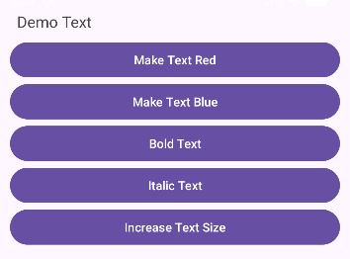
After changing the text size and the text color:
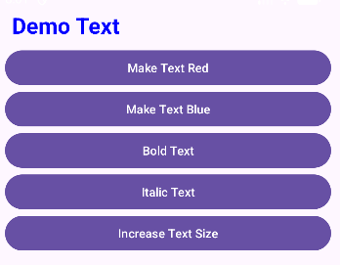
Q2: Find the “hello word” text in the XML document and modify the text.

MainActivity.java:
package com.example.demo;

import android.os.Bundle;
import androidx.appcompat.app.AppCompatActivity;

public class MainActivity extends AppCompatActivity {

@Override
protected void onCreate(Bundle savedInstanceState) {
super.onCreate(savedInstanceState);
setContentView(R.layout.activity_main);
}
}

activity_main.xml:
<?xml version="1.0" encoding="utf-8"?>
<androidx.constraintlayout.widget.ConstraintLayout xmlns:android="http://schemas.android.com/apk/res/android"
xmlns:app="http://schemas.android.com/apk/res-auto"
xmlns:tools="http://schemas.android.com/tools"
android:layout_width="match_parent"
android:layout_height="match_parent"
android:padding="16dp">

<TextView
android:layout_width="wrap_content"
android:layout_height="wrap_content"
android:layout_marginStart="148dp"
android:layout_marginTop="248dp"
android:layout_marginEnd="117dp"
android:layout_marginBottom="448dp"
android:text="Welcome to My App!"
app:layout_constraintBottom_toBottomOf="parent"
app:layout_constraintEnd_toEndOf="parent"
app:layout_constraintStart_toStartOf="parent"
app:layout_constraintTop_toTopOf="parent" />

</androidx.constraintlayout.widget.ConstraintLayout>

UI:
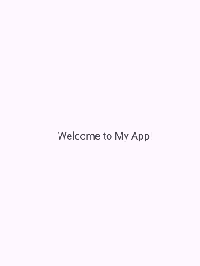

Lab 2: INTRODUCTION TO ACTIVITY AND LAYOUTS IN ANDROID

Q1: Create an app that illustrates that the activity lifecycle method being triggered by various action. Understand when onCreate(),onStart(),onResume event occur

MainActivity.java:
package com.example.demo;

import android.os.Bundle;
import android.widget.Toast;
import androidx.appcompat.app.AppCompatActivity;

public class MainActivity extends AppCompatActivity {

@Override
protected void onCreate(Bundle savedInstanceState) {
super.onCreate(savedInstanceState);
setContentView(R.layout.activity_main);
Toast.makeText(this, "onCreate() called", Toast.LENGTH_SHORT).show();
}

@Override
protected void onStart() {
super.onStart();
Toast.makeText(this, "onStart() called", Toast.LENGTH_SHORT).show();
}

@Override
protected void onResume() {
super.onResume();
Toast.makeText(this, "onResume() called", Toast.LENGTH_SHORT).show();
}
}

activity_main.xml:
<?xml version="1.0" encoding="utf-8"?>
<LinearLayout xmlns:android="http://schemas.android.com/apk/res/android"
android:layout_width="match_parent"
android:layout_height="match_parent"
android:gravity="center"
android:orientation="vertical">

<TextView
android:id="@+id/textView"
android:layout_width="wrap_content"
android:layout_height="wrap_content"
android:text="Activity Lifecycle Demo"
android:textSize="20sp"/>

</LinearLayout>

UI:
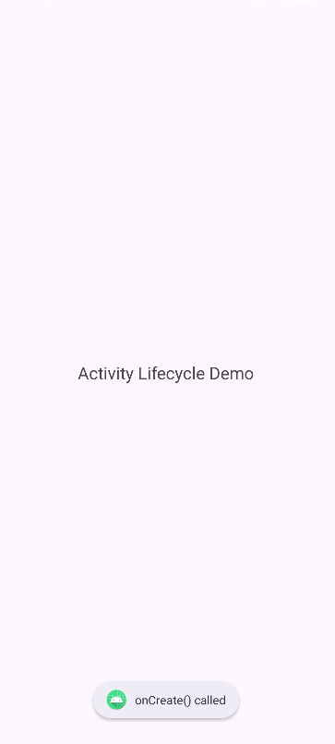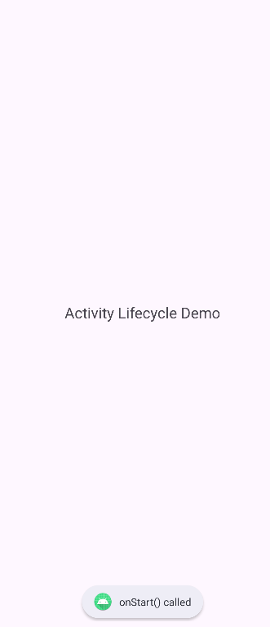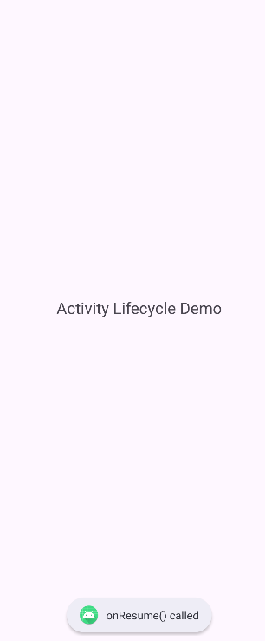

Q2: Create a Calculator app that does the function of multiplication, addition, division, subtraction but displays the result in the format of:-Num1 operator num2 = result. Back button on the next activity should get back to the calculator activity again.

MainActivity.java:
package com.example.demo;

import android.content.Intent;
import android.os.Bundle;
import android.view.View;
import android.widget.Button;
import android.widget.TextView;
import androidx.appcompat.app.AppCompatActivity;

import com.example.demo.ResultActivity;

public class MainActivity extends AppCompatActivity {

TextView display;
String num1 = "", num2 = "", operator = "";
boolean isSecondNumber = false;

@Override
protected void onCreate(Bundle savedInstanceState) {
super.onCreate(savedInstanceState);
setContentView(R.layout.activity_main);

display = findViewById(R.id.display);
}

public void onDigitClick(View view) {
Button btn = (Button) view;
if (!isSecondNumber) {
num1 += btn.getText().toString();
display.setText(num1);
} else {
num2 += btn.getText().toString();
display.setText(num2);
}
}

public void onOperatorClick(View view) {
Button btn = (Button) view;
operator = btn.getText().toString();
isSecondNumber = true;
}

public void onClearClick(View view) {
num1 = num2 = operator = "";
isSecondNumber = false;
display.setText("0");
}

public void onEqualClick(View view) {
if (num1.isEmpty() || num2.isEmpty()) return;

Intent intent = new Intent(this, ResultActivity.class);
intent.putExtra("num1", num1);
intent.putExtra("num2", num2);
intent.putExtra("operator", operator);
startActivity(intent);
}
}

activity_main.xml:
<?xml version="1.0" encoding="utf-8"?>
<LinearLayout xmlns:android="http://schemas.android.com/apk/res/android"
android:layout_width="match_parent"
android:layout_height="match_parent"
android:orientation="vertical"
android:padding="12dp">
<TextView
android:layout_width="match_parent"
android:layout_height="wrap_content"
android:text="Calculator"
android:textAlignment="center"
android:textSize="30sp"/>

<TextView
android:id="@+id/display"
android:layout_width="match_parent"
android:layout_height="50dp"
android:background="#DDDDDD"
android:gravity="end|center_vertical"
android:padding="10dp"
android:textSize="28sp"
android:text="0"/>

<GridLayout
android:layout_width="match_parent"
android:layout_height="wrap_content"
android:columnCount="4"
android:rowCount="5"
android:layout_marginTop="10dp">

<Button android:text="7" android:onClick="onDigitClick"/>
<Button android:text="8" android:onClick="onDigitClick"/>
<Button android:text="9" android:onClick="onDigitClick"/>
<Button android:text="÷" android:onClick="onOperatorClick"/>

<Button android:text="4" android:onClick="onDigitClick"/>
<Button android:text="5" android:onClick="onDigitClick"/>
<Button android:text="6" android:onClick="onDigitClick"/>
<Button android:text="×" android:onClick="onOperatorClick"/>

<Button android:text="1" android:onClick="onDigitClick"/>
<Button android:text="2" android:onClick="onDigitClick"/>
<Button android:text="3" android:onClick="onDigitClick"/>
<Button android:text="-" android:onClick="onOperatorClick"/>

<Button android:text="0" android:onClick="onDigitClick"/>
<Button android:text="C" android:onClick="onClearClick"/>
<Button android:text="=" android:onClick="onEqualClick"/>
<Button android:text="+" android:onClick="onOperatorClick"/>

</GridLayout>

</LinearLayout>

ResultAcitivity.java:
package com.example.demo;

import android.os.Bundle;
import android.widget.TextView;
import androidx.appcompat.app.AppCompatActivity;

public class ResultActivity extends AppCompatActivity {

@Override
protected void onCreate(Bundle savedInstanceState) {
super.onCreate(savedInstanceState);
setContentView(R.layout.activity_result);

TextView resultText = findViewById(R.id.resultText);

double n1 = Double.parseDouble(getIntent().getStringExtra("num1"));
double n2 = Double.parseDouble(getIntent().getStringExtra("num2"));
String op = getIntent().getStringExtra("operator");

double result = 0;
switch (op) {
case "+": result = n1 + n2; break;
case "-": result = n1 - n2; break;
case "×": result = n1 * n2; break;
case "÷": result = n2 != 0 ? n1 / n2 : 0; break;
}

resultText.setText(n1 + " " + op + " " + n2 + " = " + result);
}
}

activity_result.xml:
<?xml version="1.0" encoding="utf-8"?>
<LinearLayout xmlns:android="http://schemas.android.com/apk/res/android"
android:layout_width="match_parent"
android:layout_height="match_parent"
android:gravity="center"
android:orientation="vertical">

<TextView
android:id="@+id/resultText"
android:layout_width="wrap_content"
android:layout_height="wrap_content"
android:textSize="26sp"
android:textStyle="bold"/>

</LinearLayout>

UI:
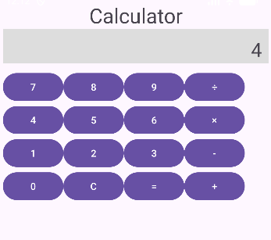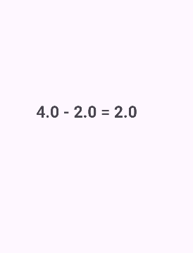

Q3: Create the following given scenario using linear and relative layout concept.
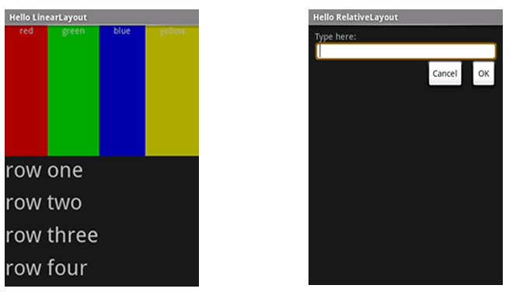
Linear Layout:

MainActivity.java:
package com.example.demo;

import android.os.Bundle;
import androidx.appcompat.app.AppCompatActivity;

public class MainActivity extends AppCompatActivity {

@Override
protected void onCreate(Bundle savedInstanceState) {
super.onCreate(savedInstanceState);
setContentView(R.layout.activity_main);
}
}

activity_main.xml:
<?xml version="1.0" encoding="utf-8"?>
<LinearLayout xmlns:android="http://schemas.android.com/apk/res/android"
android:layout_width="match_parent"
android:layout_height="match_parent"
android:orientation="vertical">
<TextView
android:layout_width="match_parent"
android:layout_height="wrap_content"
android:text="Hello Linear Layout"
android:textSize="20sp"
android:background="#8C000000"
android:textColor="@color/white" />

<LinearLayout
android:layout_width="match_parent"
android:layout_height="281dp"
android:orientation="horizontal">

<TextView
android:layout_width="0dp"
android:layout_height="match_parent"
android:layout_weight="1"
android:background="#FF0000"
android:textAlignment="center"
android:text="red"
android:textColor="#FFFFFF" />

<TextView
android:layout_width="0dp"
android:layout_height="match_parent"
android:layout_weight="1"
android:background="#00FF00"
android:textAlignment="center"
android:text="green"
android:textColor="#FFFFFF" />

<TextView
android:layout_width="0dp"
android:layout_height="match_parent"
android:layout_weight="1"
android:background="#0000FF"
android:textAlignment="center"
android:text="blue"
android:textColor="#FFFFFF" />

<TextView
android:layout_width="0dp"
android:layout_height="match_parent"
android:layout_weight="1"
android:background="#FFFF00"
android:textAlignment="center"
android:text="yellow"
android:textColor="#FFFFFF" />
</LinearLayout>

<LinearLayout
android:layout_width="match_parent"
android:layout_height="match_parent"
android:background="#222222"
android:orientation="vertical"
android:padding="16dp">

<TextView
android:layout_width="match_parent"
android:layout_height="0dp"
android:layout_weight="1"
android:text="row one"
android:textSize="22sp"
android:textColor="#FFFFFF"/>

<TextView
android:layout_width="match_parent"
android:layout_height="0dp"
android:layout_weight="1"
android:text="row two"
android:textSize="22sp"
android:textColor="#FFFFFF"/>

<TextView
android:layout_width="match_parent"
android:layout_height="0dp"
android:layout_weight="1"
android:text="row three"
android:textSize="22sp"
android:textColor="#FFFFFF"/>

<TextView
android:layout_width="match_parent"
android:layout_height="0dp"
android:layout_weight="1"
android:text="row four"
android:textSize="22sp"
android:textColor="#FFFFFF"/>

</LinearLayout>

</LinearLayout>

UI :
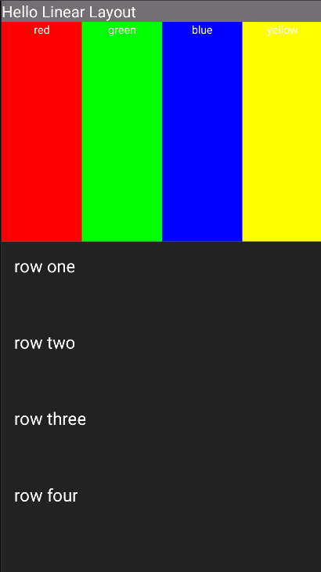

Relative Layout:

MainActivity.java:
package com.example.demo;

import android.os.Bundle;
import androidx.appcompat.app.AppCompatActivity;

public class MainActivity extends AppCompatActivity {

@Override
protected void onCreate(Bundle savedInstanceState) {
super.onCreate(savedInstanceState);
setContentView(R.layout.activity_main);
}
}

activity_main.xml:
<?xml version="1.0" encoding="utf-8"?>
<RelativeLayout xmlns:android="http://schemas.android.com/apk/res/android"
android:layout_width="match_parent"
android:layout_height="match_parent"
android:background="#111111"
>

<TextView
android:layout_width="match_parent"
android:layout_height="wrap_content"
android:text="Hello Relative Layout"
android:background="#69767474"
android:textColor="@color/white"
/>

<TextView
android:id="@+id/label"
android:layout_width="wrap_content"
android:layout_height="wrap_content"
android:text="Type here:"
android:textColor="#FFFFFF"
android:paddingLeft="16dp"
android:layout_marginTop="25dp"/>

<EditText
android:id="@+id/inputBox"
android:layout_width="match_parent"
android:layout_height="wrap_content"
android:layout_below="@id/label"
android:layout_marginTop="8dp"

android:background="@drawable/input_border"/>

<Button
android:id="@+id/cancelBtn"
android:layout_width="wrap_content"
android:layout_height="wrap_content"
android:layout_below="@id/inputBox"
android:layout_alignParentEnd="true"
android:layout_marginTop="14dp"
android:layout_marginEnd="121dp"
android:background="@drawable/flat_button"
android:text="Cancel"
android:textColor="@color/black" />

<Button
android:id="@+id/okBtn"
android:layout_width="wrap_content"
android:layout_height="wrap_content"
android:text="OK"
android:background="@drawable/flat_button"
android:textColor="@color/black"
android:layout_below="@id/inputBox"
android:layout_alignParentEnd="true"
android:layout_marginTop="12dp"
/>

</RelativeLayout>

input_border.xml:
<?xml version="1.0" encoding="utf-8"?>
<shape xmlns:android="http://schemas.android.com/apk/res/android">
<solid android:color="#FFFFFF"/>
<corners android:radius="8dp"/>
<stroke android:width="2dp" android:color="#FFD700"/>
<padding android:left="8dp" android:right="8dp" android:top="8dp" android:bottom="8dp"/>
</shape>

flat_button.xml:
<?xml version="1.0" encoding="utf-8"?>
<shape xmlns:android="http://schemas.android.com/apk/res/android">
<solid android:color="#E0E0E0"/>
<stroke android:width="1dp" android:color="#888888"/>
<corners android:radius="0dp"/>
</shape>

UI :
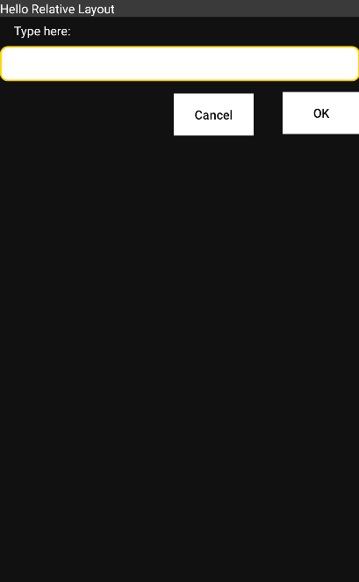

Q4: Create an app such that when the user click on the given URL typed by the user, it visits the corresponding page.

MainActivity.java:
package com.example.demo;

import android.content.Intent;
import android.net.Uri;
import android.os.Bundle;
import android.view.View;
import android.widget.EditText;
import android.widget.Toast;
import androidx.appcompat.app.AppCompatActivity;

public class MainActivity extends AppCompatActivity {

EditText urlInput;

@Override
protected void onCreate(Bundle savedInstanceState) {
super.onCreate(savedInstanceState);
setContentView(R.layout.activity_main);

urlInput = findViewById(R.id.urlInput);
}

public void openWebsite(View view) {
String url = urlInput.getText().toString().trim();

if (url.isEmpty()) {
Toast.makeText(this, "Please enter a URL", Toast.LENGTH_SHORT).show();
return;
}

if (!url.startsWith("http://") && !url.startsWith("https://")) {
url = "https://" + url;
}

Intent intent = new Intent(Intent.ACTION_VIEW, Uri.parse(url));
startActivity(intent);
}
}

activity_main.xml:
<?xml version="1.0" encoding="utf-8"?>
<LinearLayout xmlns:android="http://schemas.android.com/apk/res/android"
android:layout_width="match_parent"
android:layout_height="match_parent"
android:orientation="vertical"
android:padding="16dp">

<EditText
android:id="@+id/urlInput"
android:layout_width="match_parent"
android:layout_height="wrap_content"
android:hint="Enter URL (e.g. google.com)"
android:inputType="textUri"/>

<Button
android:layout_width="match_parent"
android:layout_height="wrap_content"
android:text="Go to Website"
android:textColor="@color/black"
android:onClick="openWebsite"/>

</LinearLayout>

UI:
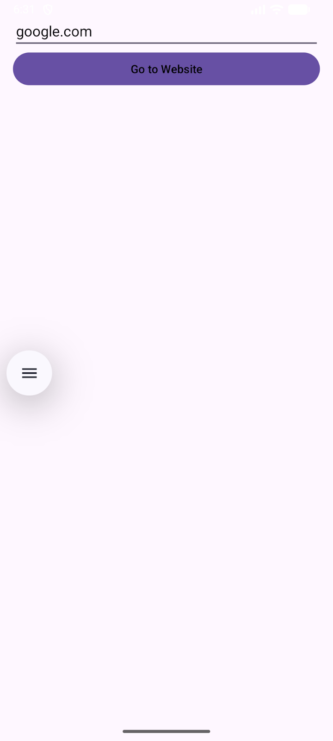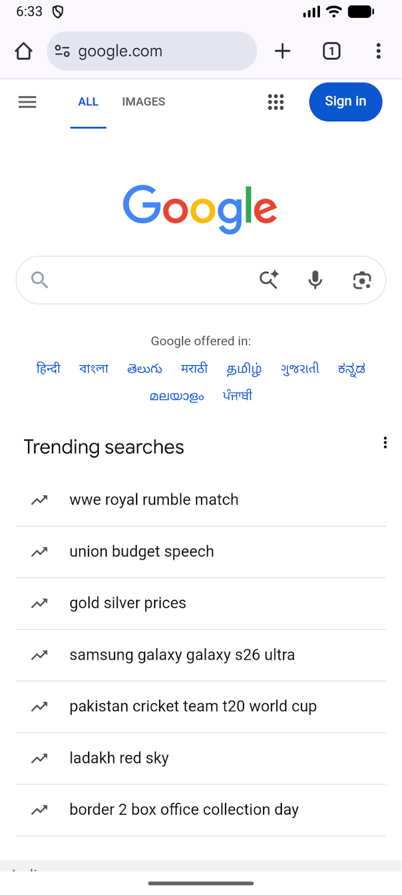

Lab 3: ACTIVITY AND LAYOUT CONTINUED

Q1: Using given scenario develop an application to perform following layout operations:
▪ List view ▪ Grid view ▪ Tab layout ▪ Table layout
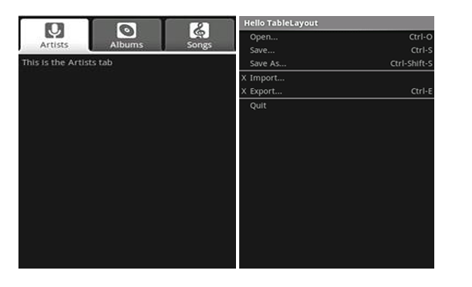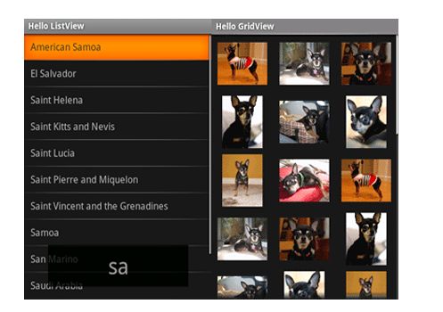
MainActivity.java:
package com.example.demo;

import android.os.Bundle;
import androidx.appcompat.app.AppCompatActivity;
import androidx.viewpager2.widget.ViewPager2;
import com.google.android.material.tabs.TabLayout;
import com.google.android.material.tabs.TabLayoutMediator;

public class MainActivity extends AppCompatActivity {

@Override
protected void onCreate(Bundle savedInstanceState) {
super.onCreate(savedInstanceState);
setContentView(R.layout.activity_main);

TabLayout tabLayout = findViewById(R.id.tabLayout);
ViewPager2 viewPager = findViewById(R.id.viewPager);

viewPager.setAdapter(new ViewPagerAdapter(this));

new TabLayoutMediator(tabLayout, viewPager, (tab, position) -> {
if (position == 0) tab.setText("Artists");
else if (position == 1) tab.setText("Albums");
else tab.setText("Songs");
}).attach();
}
}

AlbumsFragment.java:
package com.example.demo;

import android.os.Bundle;
import android.view.*;
import android.widget.GridView;
import androidx.fragment.app.Fragment;

public class AlbumsFragment extends Fragment {

int[] images = {
R.drawable.dog1, R.drawable.dog2, R.drawable.dog3,
R.drawable.dog4, R.drawable.dog5, R.drawable.dog6
};

@Override
public View onCreateView(LayoutInflater inflater, ViewGroup container, Bundle savedInstanceState) {
View v = inflater.inflate(R.layout.fragment_albums, container, false);
GridView gridView = v.findViewById(R.id.gridView);
gridView.setAdapter(new ImageAdapter(getContext(), images));
return v;
}
}

ArtistsFragment.java:
package com.example.demo;

import android.os.Bundle;
import android.view.*;
import android.widget.*;
import androidx.fragment.app.Fragment;

public class ArtistsFragment extends Fragment {

@Override
public View onCreateView(LayoutInflater inflater, ViewGroup container, Bundle savedInstanceState) {
View v = inflater.inflate(R.layout.fragment_artists, container, false);

String[] countries = {
"American Samoa","El Salvador","Saint Helena",
"Saint Kitts and Nevis","Saint Lucia","Saint Pierre and Miquelon",
"Saint Vincent and the Grenadines","Samoa","San Marino","Saudi Arabia"
};

ListView listView = v.findViewById(R.id.listView);
ArrayAdapter<String> adapter = new ArrayAdapter<>(getContext(),
R.layout.list_item_white,
R.id.itemText,
countries);

listView.setAdapter(adapter);

return v;
}
}

ImageAdapter.java:
package com.example.demo;

import android.content.Context;
import android.view.*;
import android.widget.*;

public class ImageAdapter extends BaseAdapter {

Context context;
int[] images;

public ImageAdapter(Context c, int[] imgs) {
context = c;
images = imgs;
}

public int getCount() { return images.length; }
public Object getItem(int pos) { return images[pos]; }
public long getItemId(int pos) { return pos; }

public View getView(int pos, View convertView, ViewGroup parent) {
ImageView iv = new ImageView(context);
iv.setImageResource(images[pos]);
iv.setLayoutParams(new GridView.LayoutParams(300, 300));
iv.setScaleType(ImageView.ScaleType.CENTER_CROP);
return iv;
}
}

SongsFragment.java:
package com.example.demo;

import android.os.Bundle;
import android.view.*;
import androidx.fragment.app.Fragment;

public class SongsFragment extends Fragment {
@Override
public View onCreateView(LayoutInflater inflater, ViewGroup container, Bundle savedInstanceState) {
return inflater.inflate(R.layout.fragment_songs, container, false);
}
}

ViewPagerAdapter.java:
package com.example.demo;

import androidx.annotation.NonNull;
import androidx.fragment.app.Fragment;
import androidx.fragment.app.FragmentActivity;
import androidx.viewpager2.adapter.FragmentStateAdapter;

public class ViewPagerAdapter extends FragmentStateAdapter {

public ViewPagerAdapter(@NonNull FragmentActivity fa) {
super(fa);
}

@NonNull
@Override
public Fragment createFragment(int position) {
if (position == 0) return new ArtistsFragment();
else if (position == 1) return new AlbumsFragment();
else return new SongsFragment();
}

@Override
public int getItemCount() {
return 3;
}
}

activity_main.xml:
<LinearLayout xmlns:android="http://schemas.android.com/apk/res/android"
xmlns:app="http://schemas.android.com/apk/res-auto"
android:layout_width="match_parent"
android:layout_height="match_parent"
android:orientation="vertical">

<com.google.android.material.tabs.TabLayout
android:id="@+id/tabLayout"
android:layout_width="match_parent"
android:layout_height="wrap_content"
android:background="#333333"
app:tabTextColor="@color/white"
app:tabSelectedTextColor="#FFFFFF"
app:tabIndicatorColor="#FFFFFF"/>

<androidx.viewpager2.widget.ViewPager2
android:id="@+id/viewPager"
android:layout_width="match_parent"
android:layout_height="match_parent"
/>
</LinearLayout>

fragment_albums.xml:
<GridView xmlns:android="http://schemas.android.com/apk/res/android"
android:id="@+id/gridView"
android:layout_width="match_parent"
android:layout_height="match_parent"
android:numColumns="3"
android:verticalSpacing="8dp"
android:horizontalSpacing="8dp"
android:background="#111111"
android:padding="8dp"/>

fragment_artists.xml:
<ListView xmlns:android="http://schemas.android.com/apk/res/android"
android:id="@+id/listView"
android:layout_width="match_parent"
android:layout_height="match_parent"
android:background="#111111"
android:divider="#444444"
android:dividerHeight="1dp"/>

fragment_songs.xml:
<TableLayout xmlns:android="http://schemas.android.com/apk/res/android"
android:layout_width="match_parent"
android:layout_height="match_parent"
android:background="#111111"
android:stretchColumns="*"
android:padding="10dp">

<TableRow>
<TextView android:text="Open..." android:textColor="#FFFFFF"/>
<TextView android:text="Ctrl+O" android:textColor="#AAAAAA"/>
</TableRow>

<TableRow>
<TextView android:text="Save..." android:textColor="#FFFFFF"/>
<TextView android:text="Ctrl+S" android:textColor="#AAAAAA"/>
</TableRow>

<TableRow>
<TextView android:text="Import..." android:textColor="#FFFFFF"/>
<TextView android:text="Ctrl+I" android:textColor="#AAAAAA"/>
</TableRow>

<TableRow>
<TextView android:text="Export..." android:textColor="#FFFFFF"/>
<TextView android:text="Ctrl+E" android:textColor="#AAAAAA"/>
</TableRow>

<TableRow>
<TextView android:text="Quit" android:textColor="#FFFFFF"/>
<TextView android:text="Ctrl+Q" android:textColor="#AAAAAA"/>
</TableRow>
</TableLayout>

list_item_white.xml:
<?xml version="1.0" encoding="utf-8"?>
<TextView xmlns:android="http://schemas.android.com/apk/res/android"
android:id="@+id/itemText"
android:layout_width="match_parent"
android:layout_height="wrap_content"
android:textColor="#FFFFFF"
android:textSize="16sp"
android:padding="12dp"
android:background="#111111"/>

UI:
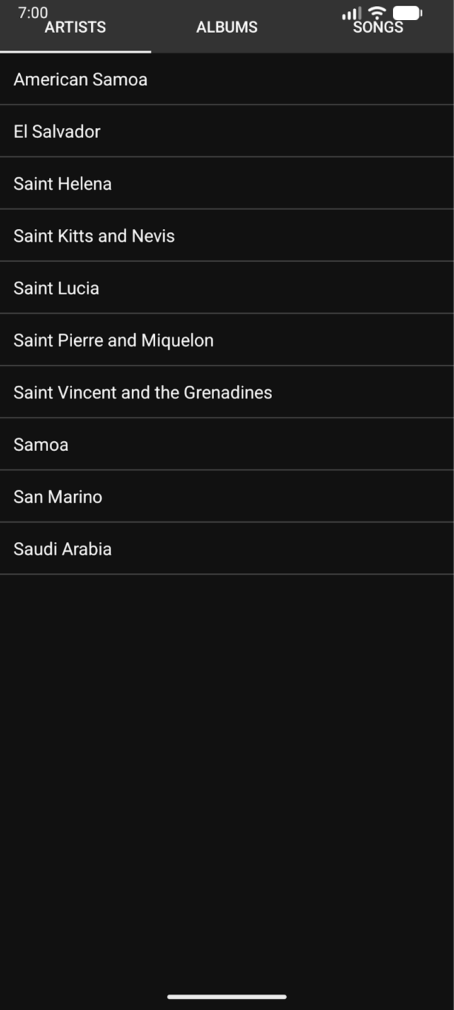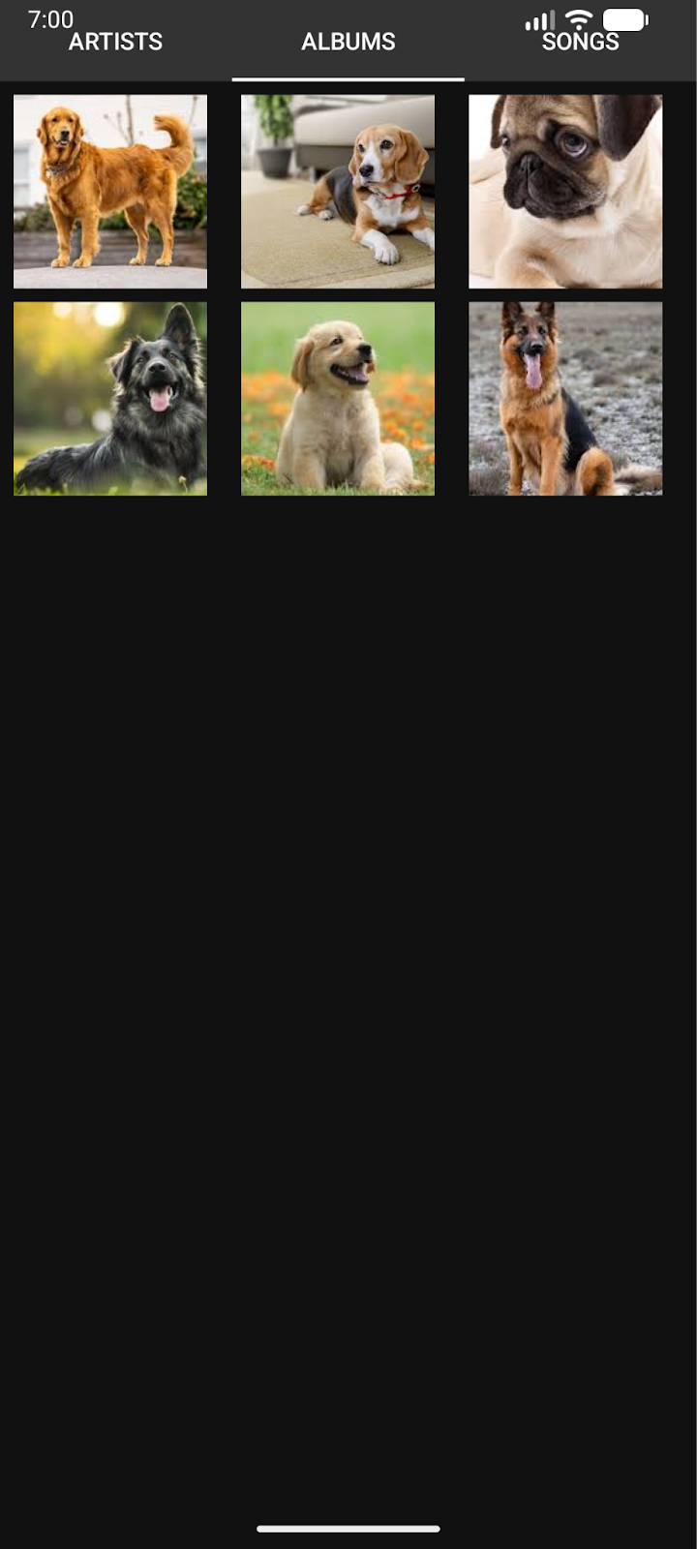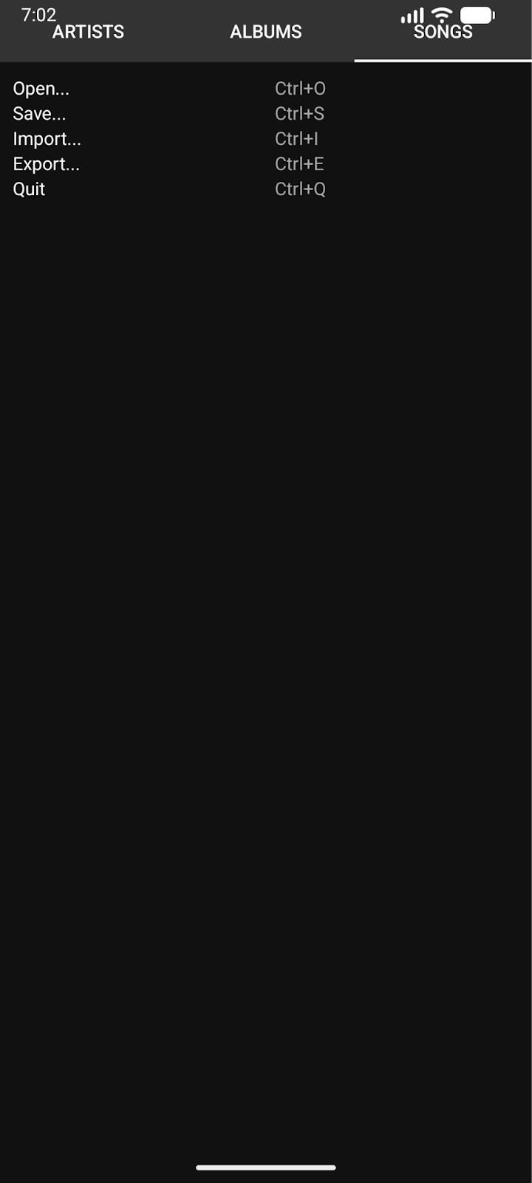

Q2: Write a program to list different sports, and when a sport is selected, display a message showing the selected sport.

MainActivity.java:
package com.example.demo;

import android.os.Bundle;
import android.view.View;
import android.widget.ArrayAdapter;
import android.widget.ListView;
import android.widget.Toast;

import androidx.appcompat.app.AppCompatActivity;

public class MainActivity extends AppCompatActivity {

ListView sportsListView;

@Override
protected void onCreate(Bundle savedInstanceState) {
super.onCreate(savedInstanceState);
setContentView(R.layout.activity_main);

sportsListView = findViewById(R.id.sportsListView);

String[] sports = {
"Cricket",
"Football",
"Tennis",
"Basketball",
"Hockey",
"Badminton",
"Volleyball"
};

ArrayAdapter<String> adapter = new ArrayAdapter<>(
this,
android.R.layout.simple_list_item_1,
sports
);

sportsListView.setAdapter(adapter);

sportsListView.setOnItemClickListener((parent, view, position, id) -> {
String selectedSport = sports[position];
Toast.makeText(MainActivity.this,
"Selected Sport: " + selectedSport,
Toast.LENGTH_SHORT).show();
});
}
}

activity_main.xml:
<?xml version="1.0" encoding="utf-8"?>
<ListView xmlns:android="http://schemas.android.com/apk/res/android"
android:id="@+id/sportsListView"
android:layout_width="match_parent"
android:layout_height="match_parent" />

UI:

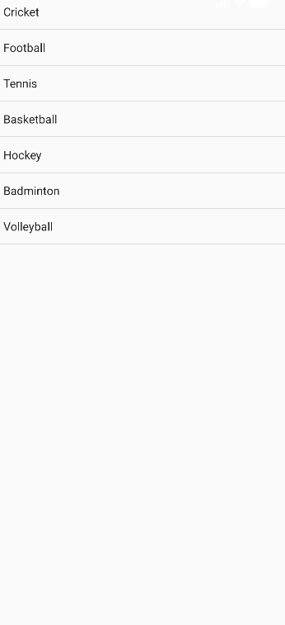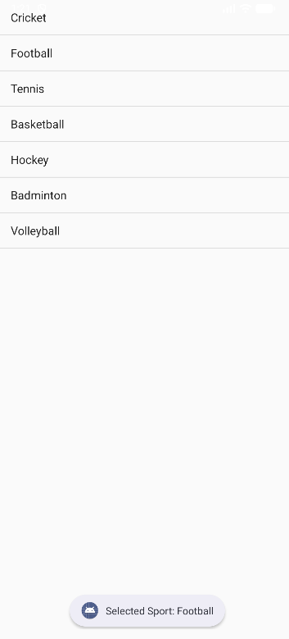

Q3: Design an news application and Implement the navigation between sections like Top Stories, Sports, and Entertainment using tab layout.

MainActivity.java:
package com.example.demo;

import android.os.Bundle;
import androidx.appcompat.app.AppCompatActivity;
import androidx.viewpager.widget.ViewPager;
import com.google.android.material.tabs.TabLayout;

public class MainActivity extends AppCompatActivity {

@Override
protected void onCreate(Bundle savedInstanceState) {
super.onCreate(savedInstanceState);
setContentView(R.layout.activity_main);

TabLayout tabLayout = findViewById(R.id.tabLayout);
ViewPager viewPager = findViewById(R.id.viewPager);

ViewPagerAdapter adapter = new ViewPagerAdapter(getSupportFragmentManager());
adapter.addFragment(new TopStoriesFragment(), "Top Stories");
adapter.addFragment(new SportsFragment(), "Sports");
adapter.addFragment(new EntertainmentFragment(), "Entertainment");

viewPager.setAdapter(adapter);
tabLayout.setupWithViewPager(viewPager);
}
}

EntertainmentFragment.java:
package com.example.demo;

import android.os.Bundle;
import android.view.LayoutInflater;
import android.view.View;
import android.view.ViewGroup;
import android.widget.ArrayAdapter;
import android.widget.ListView;

import androidx.fragment.app.Fragment;

public class EntertainmentFragment extends Fragment {

@Override
public View onCreateView(LayoutInflater inflater, ViewGroup container, Bundle savedInstanceState) {
View v = inflater.inflate(R.layout.fragment_list, container, false);
ListView listView = v.findViewById(R.id.listView);

String[] entertainmentNews = {
"New Movie Releases",
"Celebrity Interviews",
"Music Festival Updates",
"Award Show Highlights"
};

ArrayAdapter<String> adapter = new ArrayAdapter<>(getContext(),
android.R.layout.simple_list_item_1, entertainmentNews);

listView.setAdapter(adapter);
return v;
}
}

SportsFragment.java:
package com.example.demo;

import android.os.Bundle;
import android.view.LayoutInflater;
import android.view.View;
import android.view.ViewGroup;
import android.widget.ArrayAdapter;
import android.widget.ListView;

import androidx.fragment.app.Fragment;

public class SportsFragment extends Fragment {

@Override
public View onCreateView(LayoutInflater inflater, ViewGroup container, Bundle savedInstanceState) {
View v = inflater.inflate(R.layout.fragment_list, container, false);
ListView listView = v.findViewById(R.id.listView);

String[] sportsNews = {
"Football World Cup Updates",
"Cricket Series Highlights",
"Olympics Preparation",
"Tennis Grand Slam News"
};

ArrayAdapter<String> adapter = new ArrayAdapter<>(getContext(),
android.R.layout.simple_list_item_1, sportsNews);

listView.setAdapter(adapter);
return v;
}
}

TopStoriesFragment.java:
package com.example.demo;

import android.os.Bundle;
import android.view.LayoutInflater;
import android.view.View;
import android.view.ViewGroup;
import android.widget.ArrayAdapter;
import android.widget.ListView;

import androidx.fragment.app.Fragment;

public class TopStoriesFragment extends Fragment {

@Override
public View onCreateView(LayoutInflater inflater, ViewGroup container, Bundle savedInstanceState) {
View v = inflater.inflate(R.layout.fragment_list, container, false);
ListView listView = v.findViewById(R.id.listView);

String[] news = {
"Global Market Updates",
"New Technology Trends",
"Political Developments",
"Climate Change News"
};

ArrayAdapter<String> adapter = new ArrayAdapter<>(getContext(),
android.R.layout.simple_list_item_1, news);

listView.setAdapter(adapter);
return v;
}
}

ViewPagerAdapter.java:
package com.example.demo;

import androidx.annotation.NonNull;
import androidx.fragment.app.Fragment;
import androidx.fragment.app.FragmentManager;
import androidx.fragment.app.FragmentPagerAdapter;
import java.util.ArrayList;
import java.util.List;

public class ViewPagerAdapter extends FragmentPagerAdapter {

private final List<Fragment> fragmentList = new ArrayList<>();
private final List<String> fragmentTitleList = new ArrayList<>();

public ViewPagerAdapter(FragmentManager manager) {
super(manager);
}

@NonNull
@Override
public Fragment getItem(int position) {
return fragmentList.get(position);
}

@Override
public int getCount() {
return fragmentList.size();
}

public void addFragment(Fragment fragment, String title) {
fragmentList.add(fragment);
fragmentTitleList.add(title);
}

@Override
public CharSequence getPageTitle(int position) {
return fragmentTitleList.get(position);
}
}

activity_main.xml:
<?xml version="1.0" encoding="utf-8"?>
<LinearLayout xmlns:android="http://schemas.android.com/apk/res/android"
xmlns:app="http://schemas.android.com/apk/res-auto"
android:layout_width="match_parent"
android:layout_height="match_parent"
android:orientation="vertical">

<com.google.android.material.tabs.TabLayout
android:id="@+id/tabLayout"
android:layout_width="match_parent"
android:layout_height="wrap_content" />

<androidx.viewpager.widget.ViewPager
android:id="@+id/viewPager"
android:layout_width="match_parent"
android:layout_height="match_parent"/>

</LinearLayout>

fragment_list.xml:
<ListView xmlns:android="http://schemas.android.com/apk/res/android"
android:id="@+id/listView"
android:layout_width="match_parent"
android:layout_height="match_parent"/>

UI:
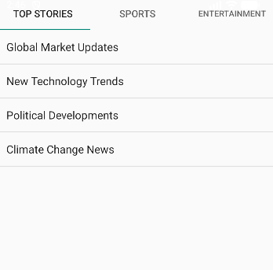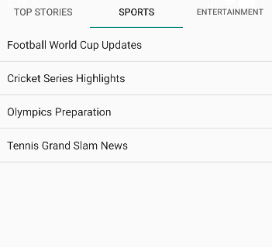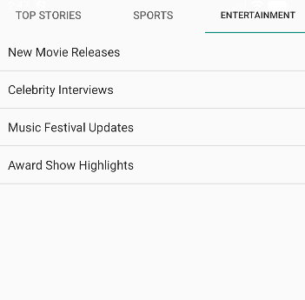
Lab 4: INPUT CONTROLS IN ANDROID

Q1: Develop a "Test App" that includes a layout with a Button and a ToggleButton. When each button is clicked, a custom Toast message should be displayed with different images as their content.

MainActivity.java:
package com.example.demo;

import android.os.Bundle;
import android.view.LayoutInflater;
import android.view.View;
import android.widget.Button;
import android.widget.ImageView;
import android.widget.TextView;
import android.widget.Toast;
import android.widget.ToggleButton;

import androidx.appcompat.app.AppCompatActivity;

public class MainActivity extends AppCompatActivity {

Button btnShow;
ToggleButton toggleShow;

@Override
protected void onCreate(Bundle savedInstanceState) {
super.onCreate(savedInstanceState);
setContentView(R.layout.activity_main);

btnShow = findViewById(R.id.btnShow);
toggleShow = findViewById(R.id.toggleShow);

btnShow.setOnClickListener(v -> showCustomToast("Button Clicked!", R.drawable.button_image));

toggleShow.setOnCheckedChangeListener((buttonView, isChecked) -> {
if (isChecked) {
showCustomToast("Toggle ON", R.drawable.toggle_on);
} else {
showCustomToast("Toggle OFF", R.drawable.toggle_off);
}
});
}

private void showCustomToast(String message, int imageRes) {
LayoutInflater inflater = getLayoutInflater();
View layout = inflater.inflate(R.layout.custom_toast, null);

ImageView image = layout.findViewById(R.id.toastImage);
TextView text = layout.findViewById(R.id.toastText);

image.setImageResource(imageRes);
text.setText(message);

Toast toast = new Toast(getApplicationContext());
toast.setDuration(Toast.LENGTH_SHORT);
toast.setView(layout);
toast.show();
}
}

activity_main.xml:
<?xml version="1.0" encoding="utf-8"?>
<LinearLayout xmlns:android="http://schemas.android.com/apk/res/android"
android:layout_width="match_parent"
android:layout_height="match_parent"
android:gravity="center"
android:orientation="vertical"
android:padding="20dp">

<Button
android:id="@+id/btnShow"
android:layout_width="wrap_content"
android:layout_height="wrap_content"
android:text="Show Toast" />

<ToggleButton
android:id="@+id/toggleShow"
android:layout_width="wrap_content"
android:layout_height="wrap_content"
android:textOn="Toast ON"
android:textOff="Toast OFF"
android:layout_marginTop="20dp" />

</LinearLayout>

custom_toast.xml:
<?xml version="1.0" encoding="utf-8"?>
<LinearLayout xmlns:android="http://schemas.android.com/apk/res/android"
android:layout_width="wrap_content"
android:layout_height="wrap_content"
android:orientation="vertical"
android:padding="10dp"
android:background="#DD000000"
android:gravity="center">

<ImageView
android:id="@+id/toastImage"
android:layout_width="80dp"
android:layout_height="80dp"
android:src="@drawable/ic_launcher_foreground" />

<TextView
android:id="@+id/toastText"
android:layout_width="wrap_content"
android:layout_height="wrap_content"
android:textColor="#FFFFFF"
android:textSize="16sp"
android:paddingTop="5dp"/>
</LinearLayout>

UI:
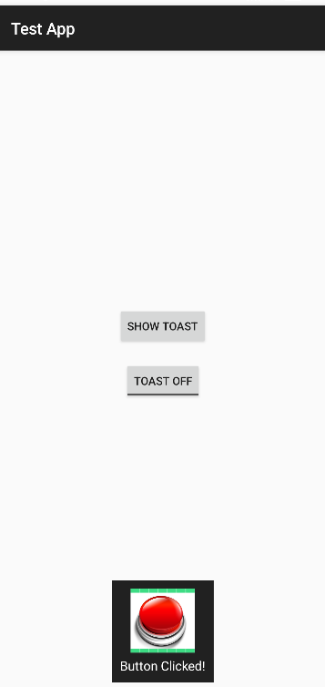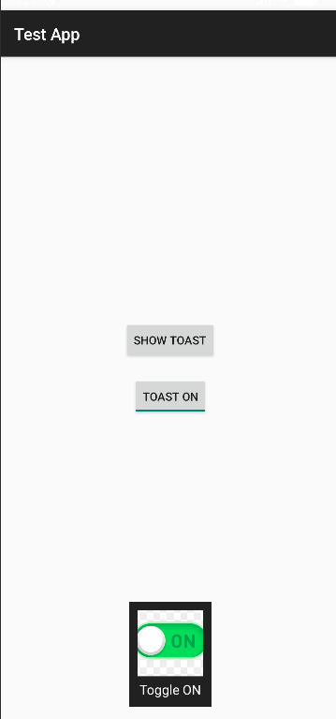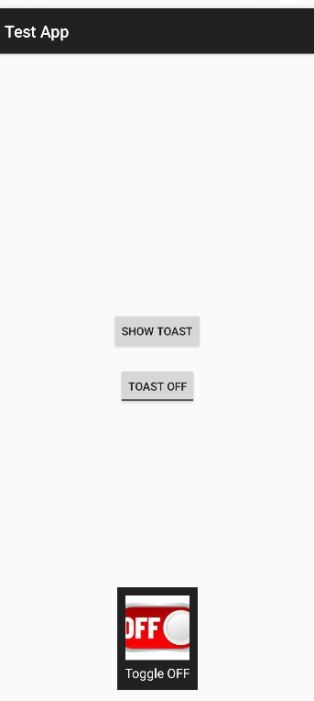

Q2: Create an app that contains a view with multiple buttons, each labeled with different Android versions. When a button is clicked, a Toast message should appear, displaying the corresponding Android version's name along with its associated icon.

MainActivity.java:
package com.example.demo;

import android.os.Bundle;
import android.view.LayoutInflater;
import android.view.View;
import android.widget.Button;
import android.widget.ImageView;
import android.widget.TextView;
import android.widget.Toast;

import androidx.appcompat.app.AppCompatActivity;

public class MainActivity extends AppCompatActivity {

@Override
protected void onCreate(Bundle savedInstanceState) {
super.onCreate(savedInstanceState);
setContentView(R.layout.activity_main);

findViewById(R.id.btnCupcake).setOnClickListener(v ->
showToast("Android Cupcake", R.drawable.cupcake));

findViewById(R.id.btnKitKat).setOnClickListener(v ->
showToast("Android KitKat", R.drawable.kitkat));

findViewById(R.id.btnLollipop).setOnClickListener(v ->
showToast("Android Lollipop", R.drawable.lollipop));

findViewById(R.id.btnPie).setOnClickListener(v ->
showToast("Android Pie", R.drawable.pie));
}

private void showToast(String message, int imageRes) {
LayoutInflater inflater = getLayoutInflater();
View layout = inflater.inflate(R.layout.custom_toast, null);

ImageView image = layout.findViewById(R.id.toastImage);
TextView text = layout.findViewById(R.id.toastText);

image.setImageResource(imageRes);
text.setText(message);

Toast toast = new Toast(getApplicationContext());
toast.setDuration(Toast.LENGTH_SHORT);
toast.setView(layout);
toast.show();
}
}

activity_main.xml:
<?xml version="1.0" encoding="utf-8"?>
<ScrollView xmlns:android="http://schemas.android.com/apk/res/android"
android:layout_width="match_parent"
android:layout_height="match_parent">

<LinearLayout
android:layout_width="match_parent"
android:layout_height="wrap_content"
android:orientation="vertical"
android:gravity="center"
android:padding="20dp">

<Button
android:id="@+id/btnCupcake"
android:layout_width="match_parent"
android:layout_height="wrap_content"
android:text="Android 1.5 - Cupcake"/>

<Button
android:id="@+id/btnKitKat"
android:layout_width="match_parent"
android:layout_height="wrap_content"
android:text="Android 4.4 - KitKat"
android:layout_marginTop="10dp"/>

<Button
android:id="@+id/btnLollipop"
android:layout_width="match_parent"
android:layout_height="wrap_content"
android:text="Android 5.0 - Lollipop"
android:layout_marginTop="10dp"/>

<Button
android:id="@+id/btnPie"
android:layout_width="match_parent"
android:layout_height="wrap_content"
android:text="Android 9 - Pie"
android:layout_marginTop="10dp"/>

</LinearLayout>
</ScrollView>

custom_toast.xml:
<?xml version="1.0" encoding="utf-8"?>
<LinearLayout xmlns:android="http://schemas.android.com/apk/res/android"
android:layout_width="wrap_content"
android:layout_height="wrap_content"
android:orientation="horizontal"
android:padding="10dp"
android:background="#DD000000"
android:gravity="center_vertical">

<ImageView
android:id="@+id/toastImage"
android:layout_width="50dp"
android:layout_height="50dp"
android:layout_marginEnd="10dp"/>

<TextView
android:id="@+id/toastText"
android:layout_width="wrap_content"
android:layout_height="wrap_content"
android:textColor="#FFFFFF"
android:textSize="16sp"/>
</LinearLayout>

UI:
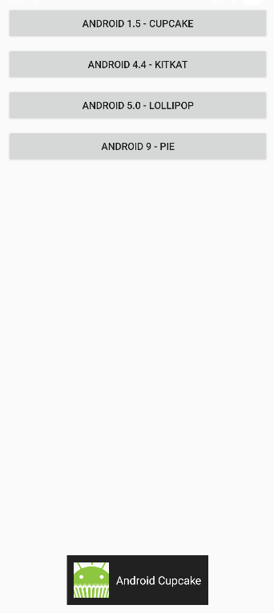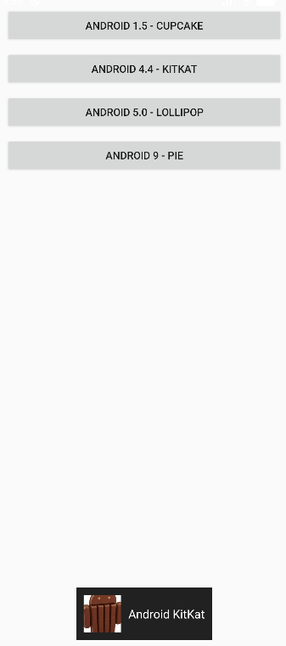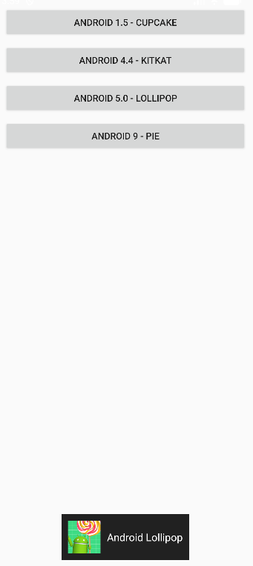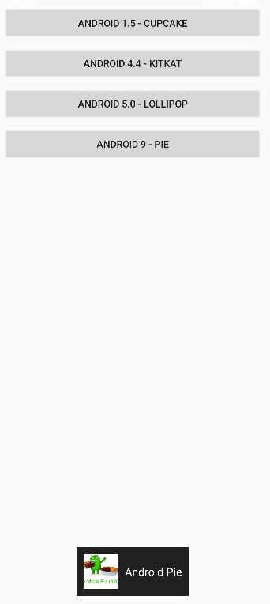

Q3: Develop a view with a ToggleButton labeled "Current Mode" that has two states: "Wi-Fi" and "Mobile Data." Based on the state of the toggle button, an image corresponding to the selected mode should appear, and a Toast message should display the current mode. Additionally, when the user clicks the "Change Mode" button, the app should switch to the corresponding mode and update the image accordingly.

MainActivity.java:
package com.example.demo;

import android.os.Bundle;
import android.widget.Button;
import android.widget.ImageView;
import android.widget.Toast;
import android.widget.ToggleButton;

import androidx.appcompat.app.AppCompatActivity;

public class MainActivity extends AppCompatActivity {

ToggleButton toggleMode;
ImageView modeImage;
Button btnChange;

@Override
protected void onCreate(Bundle savedInstanceState) {
super.onCreate(savedInstanceState);
setContentView(R.layout.activity_main);

toggleMode = findViewById(R.id.toggleMode);
modeImage = findViewById(R.id.modeImage);
btnChange = findViewById(R.id.btnChange);

toggleMode.setOnCheckedChangeListener((buttonView, isChecked) -> {
if (isChecked) {
modeImage.setImageResource(R.drawable.wifi);
Toast.makeText(this, "Current Mode: Wi-Fi", Toast.LENGTH_SHORT).show();
} else {
modeImage.setImageResource(R.drawable.mobile_data);
Toast.makeText(this, "Current Mode: Mobile Data", Toast.LENGTH_SHORT).show();
}
});

btnChange.setOnClickListener(v -> {
toggleMode.toggle();
});
}
}

activity_main.xml:
<?xml version="1.0" encoding="utf-8"?>
<LinearLayout xmlns:android="http://schemas.android.com/apk/res/android"
android:layout_width="match_parent"
android:layout_height="match_parent"
android:orientation="vertical"
android:gravity="center"
android:padding="24dp">

<ToggleButton
android:id="@+id/toggleMode"
android:layout_width="wrap_content"
android:layout_height="wrap_content"
android:textOn="Wi-Fi"
android:textOff="Mobile Data"
android:text="Current Mode" />

<ImageView
android:id="@+id/modeImage"
android:layout_width="150dp"
android:layout_height="150dp"
android:layout_marginTop="24dp"
android:src="@drawable/mobile_data" />

<Button
android:id="@+id/btnChange"
android:layout_width="wrap_content"
android:layout_height="wrap_content"
android:text="Change Mode"
android:layout_marginTop="24dp"/>

</LinearLayout>

UI:
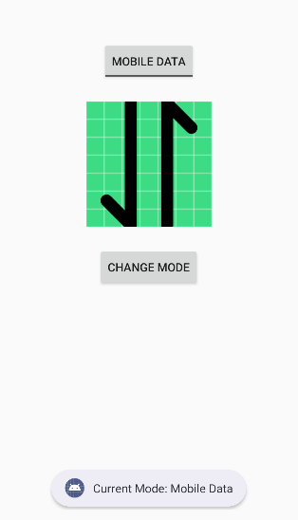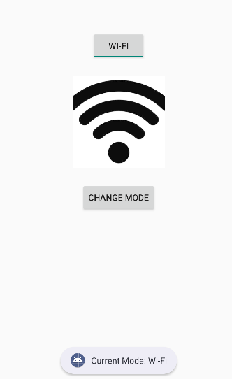

Q4: Create a “Food Ordering App” which lists food items with check boxes. Once the user checks /unchecks the item and click on the submit button display the items ordered along with cost of each item and total cost in a new activity. Once the user clicks on the submit button he/she should not be allowed to change the order i.e. he should not be allowed to change the state of the items checked.

MainActivity.java:
package com.example.demo;

import android.content.Intent;
import android.os.Bundle;
import android.widget.Button;
import android.widget.CheckBox;

import androidx.appcompat.app.AppCompatActivity;

public class MainActivity extends AppCompatActivity {

CheckBox cbBurger, cbPizza, cbPasta, cbSandwich, cbCoffee;
Button btnSubmit;

@Override
protected void onCreate(Bundle savedInstanceState) {
super.onCreate(savedInstanceState);
setContentView(R.layout.activity_main);

cbBurger = findViewById(R.id.cbBurger);
cbPizza = findViewById(R.id.cbPizza);
cbPasta = findViewById(R.id.cbPasta);
cbSandwich = findViewById(R.id.cbSandwich);
cbCoffee = findViewById(R.id.cbCoffee);
btnSubmit = findViewById(R.id.btnSubmit);

btnSubmit.setOnClickListener(v -> {

StringBuilder orderDetails = new StringBuilder();
int total = 0;

if (cbBurger.isChecked()) {
orderDetails.append("Burger - ₹120\n");
total += 120;
}
if (cbPizza.isChecked()) {
orderDetails.append("Pizza - ₹250\n");
total += 250;
}
if (cbPasta.isChecked()) {
orderDetails.append("Pasta - ₹180\n");
total += 180;
}
if (cbSandwich.isChecked()) {
orderDetails.append("Sandwich - ₹100\n");
total += 100;
}
if (cbCoffee.isChecked()) {
orderDetails.append("Coffee - ₹80\n");
total += 80;
}

Intent intent = new Intent(MainActivity.this, ResultActivity.class);
intent.putExtra("order", orderDetails.toString());
intent.putExtra("total", total);
startActivity(intent);

cbBurger.setEnabled(false);
cbPizza.setEnabled(false);
cbPasta.setEnabled(false);
cbSandwich.setEnabled(false);
cbCoffee.setEnabled(false);
btnSubmit.setEnabled(false);
});
}
}

activity_main.xml:
<?xml version="1.0" encoding="utf-8"?>
<ScrollView xmlns:android="http://schemas.android.com/apk/res/android"
android:layout_width="match_parent"
android:layout_height="match_parent">

<LinearLayout
android:layout_width="match_parent"
android:layout_height="wrap_content"
android:orientation="vertical"
android:padding="20dp">

<TextView
android:text="Select Your Food"
android:textSize="22sp"
android:textStyle="bold"
android:paddingBottom="16dp" android:layout_height="wrap_content" android:layout_width="wrap_content"/>

<CheckBox
android:id="@+id/cbBurger"
android:text="Burger - ₹120" android:layout_height="wrap_content" android:layout_width="wrap_content"/>

<CheckBox
android:id="@+id/cbPizza"
android:text="Pizza - ₹250" android:layout_height="wrap_content" android:layout_width="wrap_content"/>

<CheckBox
android:id="@+id/cbPasta"
android:text="Pasta - ₹180" android:layout_height="wrap_content" android:layout_width="wrap_content"/>

<CheckBox
android:id="@+id/cbSandwich"
android:text="Sandwich - ₹100" android:layout_height="wrap_content" android:layout_width="wrap_content"/>

<CheckBox
android:id="@+id/cbCoffee"
android:text="Coffee - ₹80" android:layout_height="wrap_content" android:layout_width="wrap_content"/>

<Button
android:id="@+id/btnSubmit"
android:layout_width="match_parent"
android:layout_height="wrap_content"
android:text="Submit Order"
android:layout_marginTop="20dp"/>

</LinearLayout>
</ScrollView>

ResultAcitivity.java:
package com.example.demo;

import android.os.Bundle;
import android.widget.TextView;

import androidx.appcompat.app.AppCompatActivity;

public class ResultActivity extends AppCompatActivity {

TextView tvOrder, tvTotal;

@Override
protected void onCreate(Bundle savedInstanceState) {
super.onCreate(savedInstanceState);
setContentView(R.layout.activity_result);

tvOrder = findViewById(R.id.tvOrder);
tvTotal = findViewById(R.id.tvTotal);

String order = getIntent().getStringExtra("order");
int total = getIntent().getIntExtra("total", 0);

tvOrder.setText(order);
tvTotal.setText("Total Cost: ₹" + total);
}
}

activity_result.xml:
<?xml version="1.0" encoding="utf-8"?>
<LinearLayout xmlns:android="http://schemas.android.com/apk/res/android"
android:layout_width="match_parent"
android:layout_height="match_parent"
android:orientation="vertical"
android:padding="20dp">

<TextView
android:text="Your Order"
android:textSize="22sp"
android:textStyle="bold"
android:paddingBottom="16dp" android:layout_height="wrap_content" android:layout_width="wrap_content"/>

<TextView
android:id="@+id/tvOrder"
android:textSize="18sp" android:layout_height="wrap_content" android:layout_width="wrap_content"/>

<TextView
android:id="@+id/tvTotal"
android:textSize="20sp"
android:textStyle="bold"
android:layout_marginTop="20dp" android:layout_height="wrap_content" android:layout_width="wrap_content"/>

</LinearLayout>

UI:
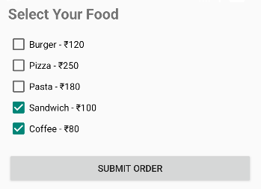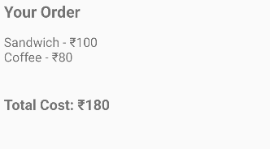

Lab 5: INPUT CONTROLS-SPINNERS, PICKERS

Q1. Develop an application named "Vehicle Parking Registration" where the user can register their vehicle for parking. The app should include a spinner that allows users to select the type of vehicle (e.g., car, bike, etc.) and text fields for entering the vehicle number and RC number. Upon clicking the submit button, the entered details should be displayed in a separate view, providing the user with options to either confirm the details or edit them. Once the user confirms the information, a toast message should appear showing a unique serial number to confirm the parking allotment.

AndroidManifest.xml
<?xml version="1.0" encoding="utf-8"?>
<manifest xmlns:android="http://schemas.android.com/apk/res/android"
xmlns:tools="http://schemas.android.com/tools">

<application
android:allowBackup="true"
android:dataExtractionRules="@xml/data_extraction_rules"
android:fullBackupContent="@xml/backup_rules"
android:icon="@mipmap/ic_launcher"
android:label="Vehicle Parking"
android:roundIcon="@mipmap/ic_launcher_round"
android:supportsRtl="true"
android:theme="@style/Theme.AppCompat.DayNight">
<activity android:name=".ConfirmationActivity"/>
<activity
android:name=".MainActivity"
android:exported="true">
<intent-filter>
<action android:name="android.intent.action.MAIN" />

<category android:name="android.intent.category.LAUNCHER" />
</intent-filter>
</activity>
</application>

</manifest>

ConfirmationActivity.java
package com.example.lab5_q1;

import android.os.Bundle;
import android.widget.Button;
import android.widget.TextView;
import android.widget.Toast;

import androidx.appcompat.app.AppCompatActivity;

import java.util.Random;

public class ConfirmationActivity extends AppCompatActivity {
TextView vehicleDetails;
Button Submit,edit;
public void onCreate(Bundle savedInstanceState) {
super.onCreate(savedInstanceState);
setContentView(R.layout.activity_confirm);
vehicleDetails=findViewById(R.id.VehicleDetails);
Submit=findViewById(R.id.buttonConfirm);
edit=findViewById(R.id.editText);
String VehicleNo=getIntent().getStringExtra("VehicleNo");
String RC=getIntent().getStringExtra("RC");
String VehicleType=getIntent().getStringExtra("VehicleType");
vehicleDetails.setText("Vehicle No: "+VehicleNo+"\n"+"RC: "+RC+"\n"+"Vehicle Type: "+VehicleType);
Submit.setOnClickListener(v->{
int serial=new Random().nextInt(1000)+1;
Toast.makeText(this, "Parking done with serial no:"+serial, Toast.LENGTH_SHORT).show();
});
edit.setOnClickListener(v->finish());
}
}

MainActivity.java

package com.example.lab5_q1;

import android.content.Intent;
import android.os.Bundle;
import android.widget.ArrayAdapter;
import android.widget.Button;
import android.widget.EditText;
import android.widget.Spinner;

import androidx.activity.EdgeToEdge;
import androidx.appcompat.app.AppCompatActivity;
import androidx.core.graphics.Insets;
import androidx.core.view.ViewCompat;
import androidx.core.view.WindowInsetsCompat;

public class MainActivity extends AppCompatActivity {
Spinner spinnerVehicle;
EditText vehicleNo;
EditText rc;
Button buttonSubmit;

@Override
protected void onCreate(Bundle savedInstanceState) {
super.onCreate(savedInstanceState);
EdgeToEdge.enable(this);
setContentView(R.layout.activity_main);
spinnerVehicle = findViewById(R.id.spinnervehicle);
vehicleNo = findViewById(R.id.vehicleNo);
rc = findViewById(R.id.rc);
buttonSubmit = findViewById(R.id.buttonSubmit);
String[] vehicles={"car","bike","truck"};
ArrayAdapter<String> adapter = new ArrayAdapter<>(
this,
android.R.layout.simple_spinner_dropdown_item,
vehicles
);
spinnerVehicle.setAdapter(adapter);
buttonSubmit.setOnClickListener(v->{
String VehicleNo=vehicleNo.getText().toString();
String RC=rc.getText().toString();
String VehicleType=spinnerVehicle.getSelectedItem().toString();
Intent intent= new Intent(MainActivity.this, ConfirmationActivity.class);
intent.putExtra("VehicleNo",VehicleNo);
intent.putExtra("RC",RC);
intent.putExtra("VehicleType",VehicleType);
startActivity(intent);
});

}
}

activity_confirm.xml
<LinearLayout xmlns:android="http://schemas.android.com/apk/res/android"
android:layout_width="match_parent"
android:layout_height="match_parent"
android:orientation="vertical">
<TextView
android:layout_width="160dp"
android:layout_height="wrap_content"

android:id="@+id/VehicleDetails"/>
<Button
android:layout_width="wrap_content"
android:layout_height="wrap_content"
android:text="Confirm"
android:id="@+id/buttonConfirm"/>
<Button
android:layout_width="wrap_content"
android:layout_height="wrap_content"
android:id="@+id/editText"
android:hint="edit"/>

</LinearLayout>

activity_main.xml

<?xml version="1.0" encoding="utf-8"?>
<androidx.constraintlayout.widget.ConstraintLayout xmlns:android="http://schemas.android.com/apk/res/android"
xmlns:app="http://schemas.android.com/apk/res-auto"
xmlns:tools="http://schemas.android.com/tools"
android:id="@+id/main"
android:layout_width="match_parent"
android:layout_height="match_parent"
android:padding="16dp"
tools:context=".MainActivity">

<TextView
android:id="@+id/TitleText"
android:layout_width="wrap_content"
android:layout_height="wrap_content"
android:text="Vehicle Parking Registration"
android:textSize="20sp"
android:textStyle="bold"
android:layout_marginTop="24dp"
app:layout_constraintEnd_toEndOf="parent"
app:layout_constraintStart_toStartOf="parent"
app:layout_constraintTop_toTopOf="parent" />

<Spinner
android:id="@+id/spinnervehicle"
android:layout_width="0dp"
android:layout_height="wrap_content"
android:layout_marginTop="20dp"
app:layout_constraintTop_toBottomOf="@+id/TitleText"
app:layout_constraintEnd_toEndOf="parent"
app:layout_constraintStart_toStartOf="parent" />

<EditText
android:id="@+id/vehicleNo"
android:layout_width="0dp"
android:layout_height="wrap_content"
android:hint="Enter vehicle number"
android:layout_marginTop="12dp"
app:layout_constraintTop_toBottomOf="@+id/spinnervehicle"
app:layout_constraintEnd_toEndOf="parent"
app:layout_constraintStart_toStartOf="parent" />

<EditText
android:id="@+id/rc"
android:layout_width="0dp"
android:layout_height="wrap_content"
android:hint="Enter RC"
android:layout_marginTop="12dp"
app:layout_constraintTop_toBottomOf="@+id/vehicleNo"
app:layout_constraintEnd_toEndOf="parent"
app:layout_constraintStart_toStartOf="parent"/>

<Button
android:id="@+id/buttonSubmit"
android:layout_width="0dp"
android:layout_height="wrap_content"
android:text="Submit"
android:layout_marginTop="24dp"
app:layout_constraintTop_toBottomOf="@+id/rc"
app:layout_constraintEnd_toEndOf="parent"
app:layout_constraintStart_toStartOf="parent"/>

</androidx.constraintlayout.widget.ConstraintLayout>

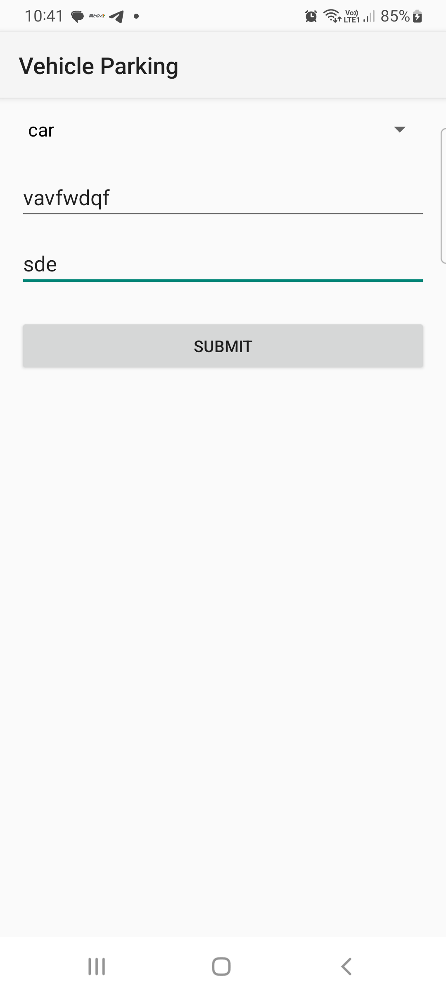

Q2. Design and develop a "Travel Ticket Booking" app where users can book tickets by selecting the source and destination from dropdown lists (spinners) and choosing the date of travel using a date picker. Include a toggle button to let users specify whether they want a one-way ticket or a round-trip ticket. The app should have "Submit" and "Reset" buttons. When the "Submit" button is clicked, display the entered details on a new screen in a structured format. The "Reset" button should clear all input fields and set the date picker to the current system date and time.

AndroidMainifest.xml:
<?xml version="1.0" encoding="utf-8"?>
<manifest xmlns:android="http://schemas.android.com/apk/res/android"
package="com.example.myapplication">
<application
android:allowBackup="true"
android:label="Travel Ticket Booking"
android:theme="@style/Theme.AppCompat.Light.DarkActionBar">
<activity android:name=".resultActivity"/>
<activity
android:name=".MainActivity"
android:exported="true">
<intent-filter>
<action android:name="android.intent.action.MAIN"/>
<category android:name="android.intent.category.LAUNCHER"/>
</intent-filter>
</activity>
</application>
</manifest>

MainActiivyt.java:
package com.example.myapplication;
import android.app.DatePickerDialog;
import android.content.Intent;
import android.os.Bundle;
import android.widget.ArrayAdapter;
import android.widget.Button;
import android.widget.EditText;
import android.widget.Spinner;
import android.widget.ToggleButton;
import androidx.activity.EdgeToEdge;
import androidx.appcompat.app.AppCompatActivity;
import java.util.Calendar;
public class MainActivity extends AppCompatActivity {
Spinner spinnersrc,spinnerdst;
Button date,btnsubmit,btnreset;
ToggleButton toggleButton;
String selectedDate="";
Calendar calendar;
@Override
protected void onCreate(Bundle savedInstanceState) {
super.onCreate(savedInstanceState);
setContentView(R.layout.activity_main);
spinnersrc=findViewById(R.id.spinnersrc);
spinnerdst=findViewById(R.id.spinnerdst);
date=findViewById(R.id.buttonDate);
toggleButton=findViewById(R.id.toggleButton);
btnsubmit=findViewById(R.id.btnSubmit);
btnreset=findViewById(R.id.btnReset);
calendar=Calendar.getInstance();
String[] cities={"Pune","Mumbai","delhi"};
ArrayAdapter<String> adapter = new ArrayAdapter<>(
this,
android.R.layout.simple_spinner_dropdown_item,
cities
);
spinnersrc.setAdapter(adapter);
spinnerdst.setAdapter(adapter);
// Date Picker
date.setOnClickListener(v -> {
int year = calendar.get(Calendar.YEAR);
int month = calendar.get(Calendar.MONTH);
int day = calendar.get(Calendar.DAY_OF_MONTH);
DatePickerDialog datePickerDialog =
new DatePickerDialog(this,
(view, y, m, d) -> {
selectedDate = d + "/" + (m + 1) + "/" + y;
date.setText(selectedDate);
},
year, month, day);
datePickerDialog.show();
});
btnsubmit.setOnClickListener(v->{
String source=spinnersrc.getSelectedItem().toString();
String destination=spinnerdst.getSelectedItem().toString();
String type=toggleButton.getText().toString();
Intent intent=new Intent(this,resultActivity.class);
intent.putExtra("Source",source);
intent.putExtra("Destination",destination);
intent.putExtra("Date",selectedDate);
intent.putExtra("Type",type);
startActivity(intent);
});
// Date Picker
date.setOnClickListener(v -> {
int year = calendar.get(Calendar.YEAR);
int month = calendar.get(Calendar.MONTH);
int day = calendar.get(Calendar.DAY_OF_MONTH);
DatePickerDialog datePickerDialog =
new DatePickerDialog(this,
(view, y, m, d) -> {
selectedDate = d + "/" + (m + 1) + "/" + y;
date.setText(selectedDate);
},
year, month, day);
datePickerDialog.show();
});
}
}

resultActivity.java:
package com.example.myapplication;
import android.os.Bundle;
import android.widget.TextView;
import androidx.appcompat.app.AppCompatActivity;
public class resultActivity extends AppCompatActivity {
TextView textResult;
@Override
protected void onCreate(Bundle savedInstanceState) {
super.onCreate(savedInstanceState);
setContentView(R.layout.activity_result);
textResult = findViewById(R.id.textResult);
String source = getIntent().getStringExtra("Source");
String destination = getIntent().getStringExtra("Destination");
String date = getIntent().getStringExtra("Date");
String tripType = getIntent().getStringExtra("Type");
textResult.setText(
"----- Ticket Details -----\n\n" +
"Source: " + source + "\n" +
"Destination: " + destination + "\n" +
"Travel Date: " + date + "\n" +
"Trip Type: " + tripType
);
}
}

activity_main.xml:
<?xml version="1.0" encoding="utf-8"?>
<androidx.constraintlayout.widget.ConstraintLayout xmlns:android="http://schemas.android.com/apk/res/android"
xmlns:app="http://schemas.android.com/apk/res-auto"
xmlns:tools="http://schemas.android.com/tools"
android:id="@+id/main"
android:layout_width="match_parent"
android:layout_height="match_parent"
android:padding="16dp"
tools:context=".MainActivity">
<TextView
android:id="@+id/TitleText"
android:layout_width="wrap_content"
android:layout_height="wrap_content"
android:text="Ticket Booking "
android:textSize="20sp"
android:textStyle="bold"
android:layout_marginTop="24dp"
app:layout_constraintEnd_toEndOf="parent"
app:layout_constraintStart_toStartOf="parent"
app:layout_constraintTop_toTopOf="parent" />
<TextView
android:id="@+id/Source"
android:layout_width="wrap_content"
android:layout_height="wrap_content"
android:text="Source "
android:textSize="20sp"
android:textStyle="bold"
android:layout_marginTop="24dp"
app:layout_constraintEnd_toEndOf="parent"
app:layout_constraintTop_toBottomOf="@+id/TitleText"
app:layout_constraintStart_toStartOf="parent"/>
<Spinner
android:id="@+id/spinnersrc"
android:layout_width="0dp"
android:layout_height="wrap_content"
android:layout_marginTop="20dp"
app:layout_constraintTop_toBottomOf="@+id/Source"
app:layout_constraintEnd_toEndOf="parent"
app:layout_constraintStart_toStartOf="parent" />
<TextView
android:id="@+id/Dest"
android:layout_width="wrap_content"
android:layout_height="wrap_content"
android:text="Destination "
android:textSize="20sp"
android:textStyle="bold"
android:layout_marginTop="24dp"
app:layout_constraintEnd_toEndOf="parent"
app:layout_constraintTop_toBottomOf="@+id/spinnersrc"
app:layout_constraintStart_toStartOf="parent"/>
<Spinner
android:id="@+id/spinnerdst"
android:layout_width="0dp"
android:layout_height="wrap_content"
android:layout_marginTop="20dp"
app:layout_constraintTop_toBottomOf="@+id/Dest"
app:layout_constraintEnd_toEndOf="parent"
app:layout_constraintStart_toStartOf="parent" />
<Button
android:layout_width="wrap_content"
android:layout_height="wrap_content"
android:text="Date"
android:id="@+id/buttonDate"
android:layout_marginTop="24dp"
app:layout_constraintTop_toBottomOf="@+id/spinnerdst"
app:layout_constraintEnd_toEndOf="parent"
app:layout_constraintStart_toStartOf="parent"/>
<ToggleButton
android:layout_width="wrap_content"
android:layout_height="wrap_content"
android:id="@+id/toggleButton"
android:textOff="one way"
android:textOn="RoundWay"
app:layout_constraintTop_toBottomOf="@+id/buttonDate"
app:layout_constraintEnd_toEndOf="parent"
app:layout_constraintStart_toStartOf="parent"/>
<!-- Submit Button -->
<Button
android:id="@+id/btnSubmit"
android:layout_width="0dp"
android:layout_height="wrap_content"
android:text="Submit"
android:layout_marginTop="24dp"
app:layout_constraintTop_toBottomOf="@id/toggleButton"
app:layout_constraintStart_toStartOf="parent"
app:layout_constraintEnd_toEndOf="parent"/>
<!-- Reset Button -->
<Button
android:id="@+id/btnReset"
android:layout_width="0dp"
android:layout_height="wrap_content"
android:text="Reset"
android:layout_marginTop="12dp"
app:layout_constraintTop_toBottomOf="@id/btnSubmit"
app:layout_constraintStart_toStartOf="parent"
app:layout_constraintEnd_toEndOf="parent"/>
</androidx.constraintlayout.widget.ConstraintLayout>

Activity_result.xml:
<?xml version="1.0" encoding="utf-8"?>
<LinearLayout xmlns:android="http://schemas.android.com/apk/res/android"
android:orientation="vertical"
android:padding="20dp"
android:layout_width="match_parent"
android:layout_height="match_parent">
<TextView
android:id="@+id/textResult"
android:textSize="18sp"
android:layout_width="match_parent"
android:layout_height="wrap_content"/>
</LinearLayout>

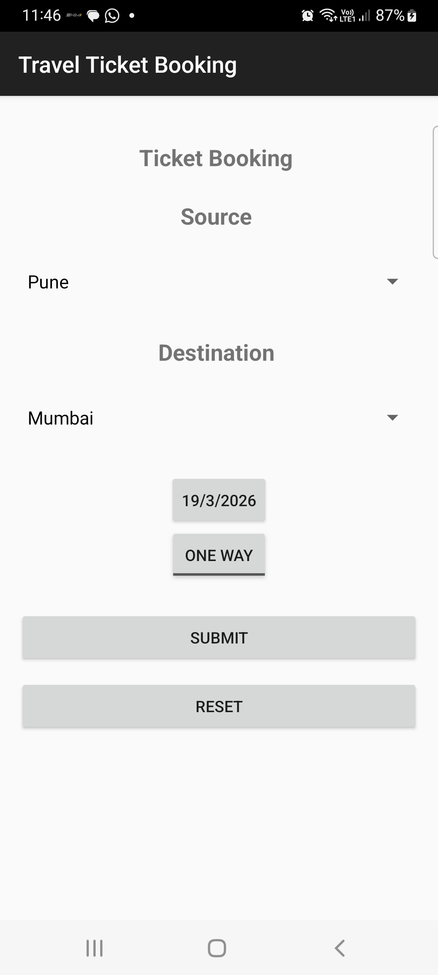

Q3. Design and develop a "Movie Ticket Booking" app where users can book tickets by selecting the movie and theatre from dropdown menus (spinners), the date of the show using a date picker, and the preferred showtime using a time picker. Include a toggle button to let users choose between a standard ticket or a premium ticket. If the "premium" option is selected, ensure the "Submit" button becomes clickable only after 12:00 PM. The app should have "Book Now" and "Reset" buttons. When the user clicks "Book Now," display the entered details along with available seats for the selected show in a new screen in a well-organized format. The "Reset" button should clear all fields and reset the date picker to the current system date. Validate all inputs to ensure correct data entry.

AndroidManifest.xml:
<?xml version="1.0" encoding="utf-8"?>
<manifest xmlns:android="http://schemas.android.com/apk/res/android"
package="com.example.myapplication">
<application
android:allowBackup="true"
android:label="Movie Ticket Booking"
android:theme="@style/Theme.AppCompat.Light.DarkActionBar">
<activity android:name=".ResultActivity"/>
<activity
android:name=".MainActivity"
android:exported="true">
<intent-filter>
<action android:name="android.intent.action.MAIN"/>
<category android:name="android.intent.category.LAUNCHER"/>
</intent-filter>
</activity>
</application>
</manifest>

MainActivtity.java:
package com.example.myapplication;
import android.app.DatePickerDialog;
import android.app.TimePickerDialog;
import android.content.Intent;
import android.os.Bundle;
import android.widget.*;
import androidx.appcompat.app.AppCompatActivity;
import java.util.Calendar;
import java.util.Random;
public class MainActivity extends AppCompatActivity {
Spinner spinnerMovie, spinnerTheatre;
Button btnDate, btnTime, btnBook, btnReset;
ToggleButton toggleTicket;
String selectedDate = "";
String selectedTime = "";
Calendar calendar;
@Override
protected void onCreate(Bundle savedInstanceState) {
super.onCreate(savedInstanceState);
setContentView(R.layout.activity_main);
spinnerMovie = findViewById(R.id.spinnerMovie);
spinnerTheatre = findViewById(R.id.spinnerTheatre);
btnDate = findViewById(R.id.btnDate);
btnTime = findViewById(R.id.btnTime);
btnBook = findViewById(R.id.btnBook);
btnReset = findViewById(R.id.btnReset);
toggleTicket = findViewById(R.id.toggleTicket);
calendar = Calendar.getInstance();
String[] movies = {"Avengers", "Inception", "Interstellar"};
String[] theatres = {"PVR", "INOX", "Cinepolis"};
ArrayAdapter<String> movieAdapter = new ArrayAdapter<>(
this, android.R.layout.simple_spinner_dropdown_item, movies);
spinnerMovie.setAdapter(movieAdapter);
ArrayAdapter<String> theatreAdapter = new ArrayAdapter<>(
this, android.R.layout.simple_spinner_dropdown_item, theatres);
spinnerTheatre.setAdapter(theatreAdapter);
// Date Picker
btnDate.setOnClickListener(v -> {
DatePickerDialog dp = new DatePickerDialog(this,
(view, year, month, day) -> {
selectedDate = day + "/" + (month + 1) + "/" + year;
btnDate.setText(selectedDate);
},
calendar.get(Calendar.YEAR),
calendar.get(Calendar.MONTH),
calendar.get(Calendar.DAY_OF_MONTH));
dp.show();
});
// Time Picker
btnTime.setOnClickListener(v -> {
TimePickerDialog tp = new TimePickerDialog(this,
(view, hour, minute) -> {
selectedTime = hour + ":" + minute;
btnTime.setText(selectedTime);
},
calendar.get(Calendar.HOUR_OF_DAY),
calendar.get(Calendar.MINUTE),
true);
tp.show();
});
// Premium rule
toggleTicket.setOnCheckedChangeListener((buttonView, isChecked) -> {
if (isChecked) {
int currentHour = Calendar.getInstance().get(Calendar.HOUR_OF_DAY);
if (currentHour < 12) {
btnBook.setEnabled(false);
Toast.makeText(this,
"Premium booking allowed only after 12 PM",
Toast.LENGTH_LONG).show();
} else {
btnBook.setEnabled(true);
}
} else {
btnBook.setEnabled(true);
}
});
// Book Now
btnBook.setOnClickListener(v -> {
if (selectedDate.isEmpty() || selectedTime.isEmpty()) {
Toast.makeText(this,
"Please select date and time",
Toast.LENGTH_SHORT).show();
return;
}
String movie = spinnerMovie.getSelectedItem().toString();
String theatre = spinnerTheatre.getSelectedItem().toString();
String ticketType = toggleTicket.isChecked() ? "Premium" : "Standard";
int seats = new Random().nextInt(50) + 1;
Intent intent = new Intent(MainActivity.this, ResultActivity.class);
intent.putExtra("movie", movie);
intent.putExtra("theatre", theatre);
intent.putExtra("date", selectedDate);
intent.putExtra("time", selectedTime);
intent.putExtra("ticketType", ticketType);
intent.putExtra("seats", seats);
startActivity(intent);
});
// Reset
btnReset.setOnClickListener(v -> {
spinnerMovie.setSelection(0);
spinnerTheatre.setSelection(0);
toggleTicket.setChecked(false);
selectedDate = "";
selectedTime = "";
btnDate.setText("Select Show Date");
btnTime.setText("Select Showtime");
});
}
}

ResultActivity.java:
package com.example.myapplication;
import android.os.Bundle;
import android.widget.TextView;
import androidx.appcompat.app.AppCompatActivity;
public class ResultActivity extends AppCompatActivity {
@Override
protected void onCreate(Bundle savedInstanceState) {
super.onCreate(savedInstanceState);
setContentView(R.layout.activity_result);
TextView textResult = findViewById(R.id.textResult);
String movie = getIntent().getStringExtra("movie");
String theatre = getIntent().getStringExtra("theatre");
String date = getIntent().getStringExtra("date");
String time = getIntent().getStringExtra("time");
String ticketType = getIntent().getStringExtra("ticketType");
int seats = getIntent().getIntExtra("seats", 0);
textResult.setText(
"----- Booking Details -----\n\n" +
"Movie: " + movie + "\n" +
"Theatre: " + theatre + "\n" +
"Date: " + date + "\n" +
"Time: " + time + "\n" +
"Ticket Type: " + ticketType + "\n" +
"Available Seats: " + seats
);
}
}

activity_main.xml:
<?xml version="1.0" encoding="utf-8"?>
<ScrollView xmlns:android="http://schemas.android.com/apk/res/android"
android:layout_width="match_parent"
android:layout_height="match_parent"
android:padding="16dp">
<LinearLayout
android:orientation="vertical"
android:layout_width="match_parent"
android:layout_height="wrap_content">
<TextView
android:text="Movie Ticket Booking"
android:textSize="20sp"
android:textStyle="bold"
android:layout_marginBottom="20dp"
android:layout_width="wrap_content"
android:layout_height="wrap_content"/>
<Spinner
android:id="@+id/spinnerMovie"
android:layout_width="match_parent"
android:layout_height="wrap_content"/>
<Spinner
android:id="@+id/spinnerTheatre"
android:layout_width="match_parent"
android:layout_height="wrap_content"
android:layout_marginTop="16dp"/>
<Button
android:id="@+id/btnDate"
android:text="Select Show Date"
android:layout_width="match_parent"
android:layout_height="wrap_content"
android:layout_marginTop="16dp"/>
<Button
android:id="@+id/btnTime"
android:text="Select Showtime"
android:layout_width="match_parent"
android:layout_height="wrap_content"
android:layout_marginTop="16dp"/>
<ToggleButton
android:id="@+id/toggleTicket"
android:textOn="Premium Ticket"
android:textOff="Standard Ticket"
android:layout_width="match_parent"
android:layout_height="wrap_content"
android:layout_marginTop="16dp"/>
<Button
android:id="@+id/btnBook"
android:text="Book Now"
android:layout_width="match_parent"
android:layout_height="wrap_content"
android:layout_marginTop="20dp"/>
<Button
android:id="@+id/btnReset"
android:text="Reset"
android:layout_width="match_parent"
android:layout_height="wrap_content"
android:layout_marginTop="10dp"/>
</LinearLayout>
</ScrollView>

Actvity_result.xml:
<?xml version="1.0" encoding="utf-8"?>
<LinearLayout xmlns:android="http://schemas.android.com/apk/res/android"
android:orientation="vertical"
android:padding="20dp"
android:layout_width="match_parent"
android:layout_height="match_parent">
<TextView
android:id="@+id/textResult"
android:textSize="18sp"
android:layout_width="match_parent"
android:layout_height="wrap_content"/>
</LinearLayout>

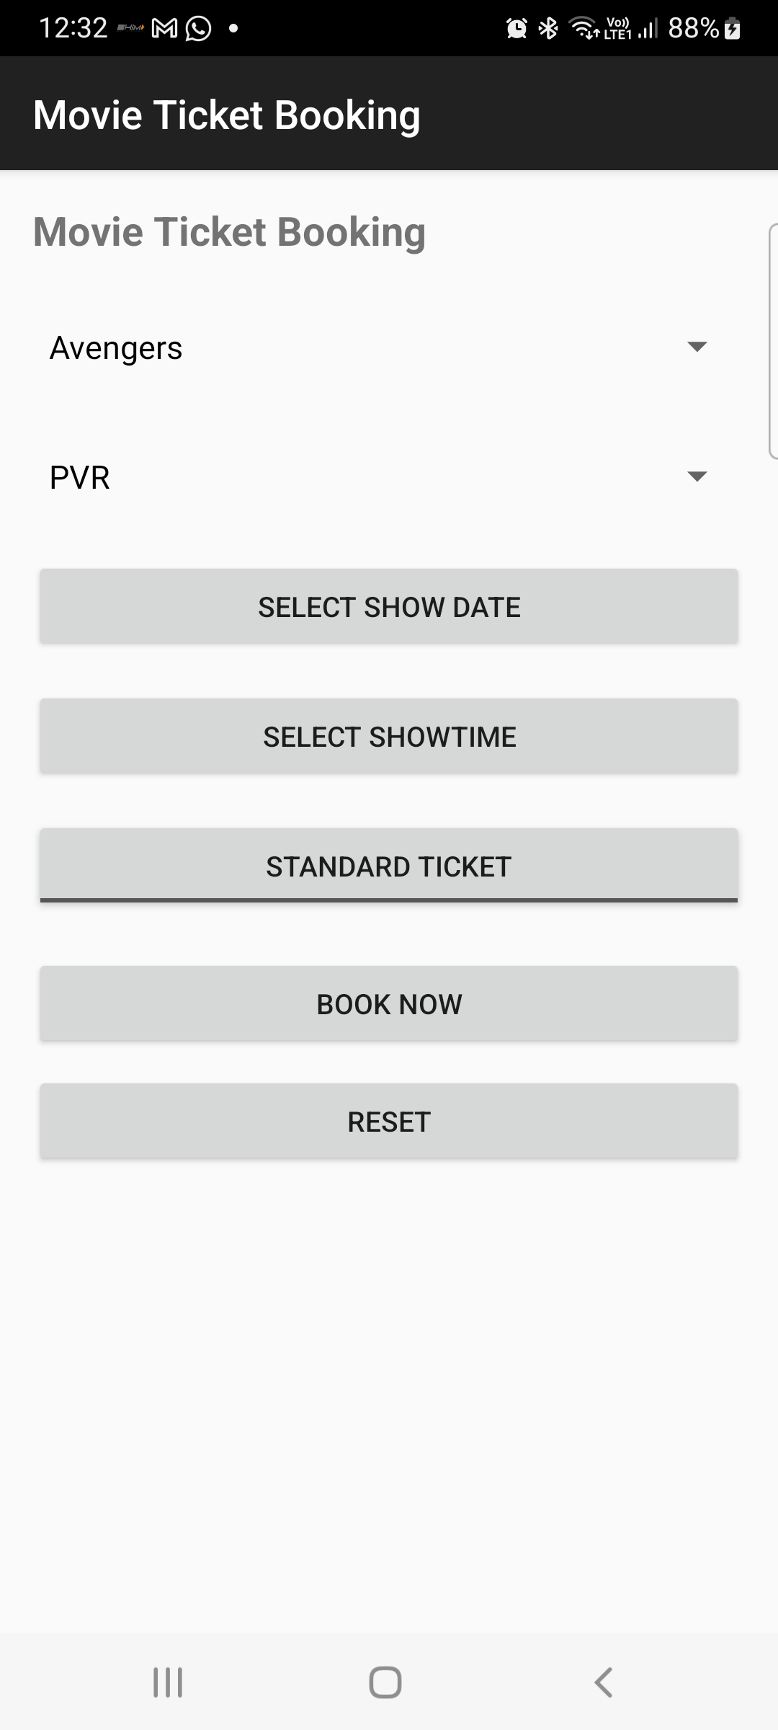

Lab6: INTRODUCTION TO MENU

Q1
XYZ Fitness Center: Home Page Design
Objective: Create a Fitness Center home page using an Options Menu with two distinct functional areas.
Part A: Functional Menu Items
Create standard menu options that display specific information when selected:
- Workout Plans: List programs like Weight Loss and Cardio.
- Trainers: Show names, specializations, and photos.
- Membership: Display packages and pricing details.
Part B: Icon-Based Menu Items
Implement action icons in the app bar (instead of text) for quick navigation:
- Home Icon: Navigates to the Homepage.
- About Us Icon: Displays information about the fitness center.
- Contact Us Icon: Shows contact details.

AndroidManifest.xml:
<?xml version="1.0" encoding="utf-8"?>
<manifest xmlns:android="http://schemas.android.com/apk/res/android"
package="com.example.myapplication">
<application
android:allowBackup="true"
android:label="Digital Transformation"
android:theme="@style/Theme.AppCompat.Light.DarkActionBar">
<activity
android:name=".MainActivity"
android:exported="true">
<intent-filter>
<action android:name="android.intent.action.MAIN"/>
<category android:name="android.intent.category.LAUNCHER"/>
</intent-filter>
</activity>
</application>
</manifest>
MainActivity.java:
package com.example.myapplication;
import android.os.Bundle;
import android.view.Menu;
import android.view.MenuItem;
import android.widget.TextView;
import androidx.appcompat.app.AppCompatActivity;
import androidx.appcompat.widget.Toolbar;
public class MainActivity extends AppCompatActivity {
TextView txtContent;
@Override
protected void onCreate(Bundle savedInstanceState) {
super.onCreate(savedInstanceState);
setContentView(R.layout.activity_main);
txtContent = findViewById(R.id.txtContent);
}
@Override
public boolean onCreateOptionsMenu(Menu menu) {
getMenuInflater().inflate(R.menu.menu_main, menu);
return true;
}
@Override
public boolean onOptionsItemSelected(MenuItem item) {
int id = item.getItemId();
if (id == R.id.workout) {
txtContent.setText(
"🏋️ Workout Plans\n\n" +
"• Weight Loss\n" +
"• Cardio\n" +
"• Muscle Gain"
);
}
else if (id == R.id.trainers) {
txtContent.setText(
"👨‍🏫 Trainers\n\n" +
"• John – Strength Training\n" +
"• Sarah – Cardio Specialist"
);
}
else if (id == R.id.membership) {
txtContent.setText("Membership:\nBasic - ₹2000/month\nPremium - ₹3500/month");
}
else if (id == R.id.home) {
txtContent.setText("Welcome to XYZ Fitness Center!");
}
else if (id == R.id.about) {
txtContent.setText("About Us:\nWe provide professional fitness training.");
}
else if (id == R.id.contact) {
txtContent.setText("Contact Us:\nPhone: 9876543210\nEmail: xyzfitness@gmail.com");
}
return true;
}
}

res->drawable-> about.jpg:


Contact.jpg:


Home.png:


activity_main.xml:
<?xml version="1.0" encoding="utf-8"?>
<LinearLayout
xmlns:android="http://schemas.android.com/apk/res/android"
xmlns:app="http://schemas.android.com/apk/res-auto"
android:orientation="vertical"
android:layout_width="match_parent"
android:layout_height="match_parent"
android:background="#F5F5F5">
<androidx.appcompat.widget.Toolbar
android:id="@+id/toolbar"
android:layout_width="match_parent"
android:layout_height="56dp"
android:background="#1E1E1E"
android:elevation="6dp"
android:title="XYZ Fitness Center"
android:titleTextColor="@android:color/white"/>
<TextView
android:id="@+id/txtContent"
android:layout_margin="16dp"
android:padding="16dp"
android:textSize="18sp"
android:textColor="#333333"
android:background="@android:color/white"
android:elevation="4dp"
android:layout_width="match_parent"
android:layout_height="wrap_content"/>
</LinearLayout>

Res-> menu-> menu_main.xml:
<?xml version="1.0" encoding="utf-8"?>
<menu xmlns:android="http://schemas.android.com/apk/res/android"
xmlns:app="http://schemas.android.com/apk/res-auto">
<item
android:id="@+id/workout"
android:title="Workout Plans" />
<item
android:id="@+id/trainers"
android:title="Trainers" />
<item
android:id="@+id/membership"
android:title="Membership" />
<item
android:id="@+id/home"
android:icon="@drawable/home"
android:title="Home"
app:showAsAction="always" />
<item
android:id="@+id/about"
android:icon="@drawable/about"
android:title="About"
app:showAsAction="always" />
<item
android:id="@+id/contact"
android:icon="@drawable/contact"
android:title="Contact"
app:showAsAction="always" />
</menu>

Res-> values-> themes-> themes.xml:
<resources xmlns:tools="http://schemas.android.com/tools">
<style name="Theme.MyApplication" parent="Theme.MaterialComponents.DayNight.NoActionBar">
<item name="colorPrimary">@color/purple_500</item>
<item name="colorPrimaryVariant">@color/purple_700</item>
<item name="colorOnPrimary">@color/white</item>
<item name="colorSecondary">@color/teal_200</item>
<item name="colorSecondaryVariant">@color/teal_700</item>
<item name="colorOnSecondary">@color/black</item>
<item name="android:statusBarColor">?attr/colorPrimaryVariant</item>
</style>
</resources>

Values->colors.xml:
<?xml version="1.0" encoding="utf-8"?>
<resources>
<color name="purple_500">#6200EE</color>
<color name="purple_700">#3700B3</color>
<color name="teal_200">#03DAC5</color>
<color name="teal_700">#018786</color>
<color name="black">#000000</color>
<color name="white">#FFFFFF</color>
</resources>

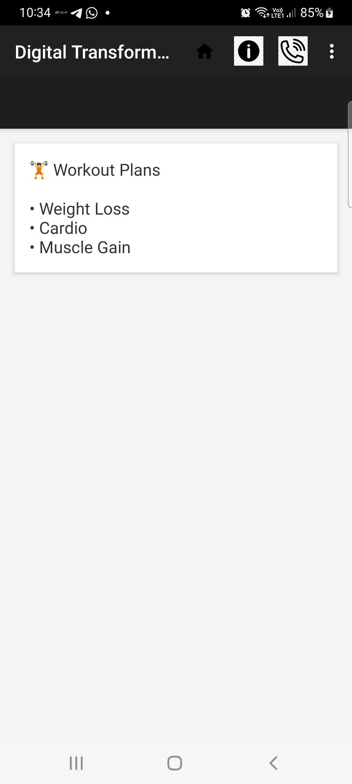

Lab7: Menus

Q1. Design and develop an application that displays a list of installed applications on your device. On long press of any application, display the following options: a) Show whether the application is a system app or user-installed. b) Provide options to open the app, uninstall it, or view its details (e.g., version, storage usage). c) Indicate whether the app has special permissions enabled, like location or camera access. When an option like "View Details" is selected, navigate to a detailed view showing the app's permissions, size, and version. For the "Uninstall" option, prompt the user for confirmation before proceeding.

AndroidManifest.xml
<manifest xmlns:android="http://schemas.android.com/apk/res/android"
package="com.example.applist">

<uses-permission android:name="android.permission.QUERY_ALL_PACKAGES"/>

<application
android:theme="@style/Theme.AppCompat.Light.DarkActionBar"
android:label="Installed Apps">

<activity android:name=".AppDetailsActivity"/>
<activity android:name=".MainActivity">
<intent-filter>
<action android:name="android.intent.action.MAIN"/>
<category android:name="android.intent.category.LAUNCHER"/>
</intent-filter>
</activity>

</application>
</manifest>

activity_main.xml
<LinearLayout xmlns:android="http://schemas.android.com/apk/res/android"
android:layout_width="match_parent"
android:layout_height="match_parent">

<ListView
android:id="@+id/listView"
android:layout_width="match_parent"
android:layout_height="match_parent"/>
</LinearLayout>

MainActivity.java
package com.example.applist;

import android.app.AlertDialog;
import android.content.Intent;
import android.content.pm.ApplicationInfo;
import android.content.pm.PackageManager;
import android.net.Uri;
import android.os.Bundle;
import android.widget.ArrayAdapter;
import android.widget.ListView;
import android.widget.Toast;

import androidx.appcompat.app.AppCompatActivity;

import java.util.ArrayList;
import java.util.List;

public class MainActivity extends AppCompatActivity {

ListView listView;
PackageManager pm;
List<ApplicationInfo> apps;
List<String> appNames;

@Override
protected void onCreate(Bundle savedInstanceState) {
super.onCreate(savedInstanceState);
setContentView(R.layout.activity_main);

listView = findViewById(R.id.listView);
pm = getPackageManager();

apps = pm.getInstalledApplications(PackageManager.GET_META_DATA);
appNames = new ArrayList<>();

for (ApplicationInfo app : apps) {
appNames.add(pm.getApplicationLabel(app).toString());
}

ArrayAdapter<String> adapter =
new ArrayAdapter<>(this,
android.R.layout.simple_list_item_1,
appNames);

listView.setAdapter(adapter);

listView.setOnItemLongClickListener((parent, view, position, id) -> {
showOptions(position);
return true;
});
}

private void showOptions(int position) {
ApplicationInfo app = apps.get(position);

String[] options = {
"App Type",
"Open App",
"Uninstall App",
"View Details"
};

new AlertDialog.Builder(this)
.setTitle(pm.getApplicationLabel(app))
.setItems(options, (dialog, which) -> {

switch (which) {

case 0: // System or User
boolean isSystem =
(app.flags & ApplicationInfo.FLAG_SYSTEM) != 0;
Toast.makeText(this,
isSystem ? "System App" : "User Installed App",
Toast.LENGTH_SHORT).show();
break;

case 1: // Open
Intent launch =
pm.getLaunchIntentForPackage(app.packageName);
if (launch != null)
startActivity(launch);
break;

case 2: // Uninstall
confirmUninstall(app.packageName);
break;

case 3: // View details
Intent intent =
new Intent(this, AppDetailsActivity.class);
intent.putExtra("pkg", app.packageName);
startActivity(intent);
break;
}
})
.show();
}

private void confirmUninstall(String pkg) {
new AlertDialog.Builder(this)
.setTitle("Uninstall")
.setMessage("Are you sure?")
.setPositiveButton("Yes", (d, w) -> {
Intent i = new Intent(Intent.ACTION_DELETE);
i.setData(Uri.parse("package:" + pkg));
startActivity(i);
})
.setNegativeButton("No", null)
.show();
}
}

activity_details.xml

<LinearLayout xmlns:android="http://schemas.android.com/apk/res/android"
android:orientation="vertical"
android:padding="16dp"
android:layout_width="match_parent"
android:layout_height="match_parent">

<TextView android:id="@+id/tvName"/>
<TextView android:id="@+id/tvVersion"/>
<TextView android:id="@+id/tvSize"/>
<TextView android:id="@+id/tvPermissions"/>
</LinearLayout>

AppDetailsActivity.java
package com.example.applist;

import android.content.pm.PackageInfo;
import android.content.pm.PackageManager;
import android.os.Bundle;
import android.widget.TextView;

import androidx.appcompat.app.AppCompatActivity;

import java.io.File;

public class AppDetailsActivity extends AppCompatActivity {

@Override
protected void onCreate(Bundle savedInstanceState) {
super.onCreate(savedInstanceState);
setContentView(R.layout.activity_details);

TextView tvName = findViewById(R.id.tvName);
TextView tvVersion = findViewById(R.id.tvVersion);
TextView tvSize = findViewById(R.id.tvSize);
TextView tvPermissions = findViewById(R.id.tvPermissions);

String pkg = getIntent().getStringExtra("pkg");

try {
PackageManager pm = getPackageManager();
PackageInfo info =
pm.getPackageInfo(pkg, PackageManager.GET_PERMISSIONS);

tvName.setText("App: " +
pm.getApplicationLabel(info.applicationInfo));

tvVersion.setText("Version: " + info.versionName);

File file =
new File(info.applicationInfo.sourceDir);
long size = file.length() / (1024 * 1024);
tvSize.setText("Size: " + size + " MB");

StringBuilder perms = new StringBuilder("Permissions:\n");

if (info.requestedPermissions != null) {
for (String p : info.requestedPermissions) {
if (p.contains("CAMERA") || p.contains("LOCATION"))
perms.append(p).append("\n");
}
}

tvPermissions.setText(perms.toString());

} catch (Exception e) {
e.printStackTrace();
}
}
}

Q2. Create a View with the name “My Menu ” which contains an image as an icon.On click of that icon it shows a submenu as ”Image -1”,”Image -2” .On click of each item that particular image should be displayed with the corresponding content in the Toast.

AndroidManifest.xml:
<?xml version="1.0" encoding="utf-8"?>
<manifest xmlns:android="http://schemas.android.com/apk/res/android"
package="com.example.myapplication">
<application
android:allowBackup="true"
android:label="My Menu"
android:theme="@style/Theme.AppCompat.Light.DarkActionBar">
<activity
android:name=".MainActivity"
android:exported="true">
<intent-filter>
<action android:name="android.intent.action.MAIN"/>
<category android:name="android.intent.category.LAUNCHER"/>
</intent-filter>
</activity>
</application>
</manifest>

MainActivity.java:
package com.example.myapplication;
import android.os.Bundle;
import android.widget.ImageView;
import android.widget.PopupMenu;
import android.widget.Toast;
import androidx.appcompat.app.AppCompatActivity;
public class MainActivity extends AppCompatActivity {
ImageView menuIcon, displayImage;
@Override
protected void onCreate(Bundle savedInstanceState) {
super.onCreate(savedInstanceState);
setContentView(R.layout.activity_main);
menuIcon = findViewById(R.id.menuIcon);
displayImage = findViewById(R.id.displayImage);
// When menu icon is clicked
menuIcon.setOnClickListener(view -> {
// Create popup menu
PopupMenu popupMenu =
new PopupMenu(MainActivity.this, view);
// Load menu items
popupMenu.getMenuInflater()
.inflate(R.menu.popup_menu,
popupMenu.getMenu());
// Handle menu item click
popupMenu.setOnMenuItemClickListener(item -> {
if (item.getItemId() == R.id.image1) {
// Set Image 1
displayImage.setImageResource(
android.R.drawable.ic_menu_camera);
Toast.makeText(MainActivity.this,
"Image - 1 Selected",
Toast.LENGTH_SHORT).show();
return true;
}
else if (item.getItemId() == R.id.image2) {
// Set Image 2
displayImage.setImageResource(
android.R.drawable.ic_menu_gallery);
Toast.makeText(MainActivity.this,
"Image - 2 Selected",
Toast.LENGTH_SHORT).show();
return true;
}
return false;
});
// Show popup
popupMenu.show();
});
}
}

activty_main.xml:
<?xml version="1.0" encoding="utf-8"?>
<LinearLayout xmlns:android="http://schemas.android.com/apk/res/android"
android:layout_width="match_parent"
android:layout_height="match_parent"
android:orientation="vertical"
android:gravity="center"
android:padding="16dp">
<!-- Title -->
<TextView
android:layout_width="wrap_content"
android:layout_height="wrap_content"
android:text="My Menu"
android:textSize="22sp"
android:layout_marginBottom="20dp"/>
<!-- Menu Icon -->
<ImageView
android:id="@+id/menuIcon"
android:layout_width="100dp"
android:layout_height="100dp"
android:src="@android:drawable/ic_menu_more"
android:contentDescription="Menu Icon"/>
<!-- Display Image -->
<ImageView
android:id="@+id/displayImage"
android:layout_width="200dp"
android:layout_height="200dp"
android:layout_marginTop="30dp"/>
</LinearLayout>

Res->menu->popup_menu.xml:
<?xml version="1.0" encoding="utf-8"?>
<menu xmlns:android="http://schemas.android.com/apk/res/android">
<item
android:id="@+id/image1"
android:title="Image - 1"/>
<item
android:id="@+id/image2"
android:title="Image - 2"/>
</menu>
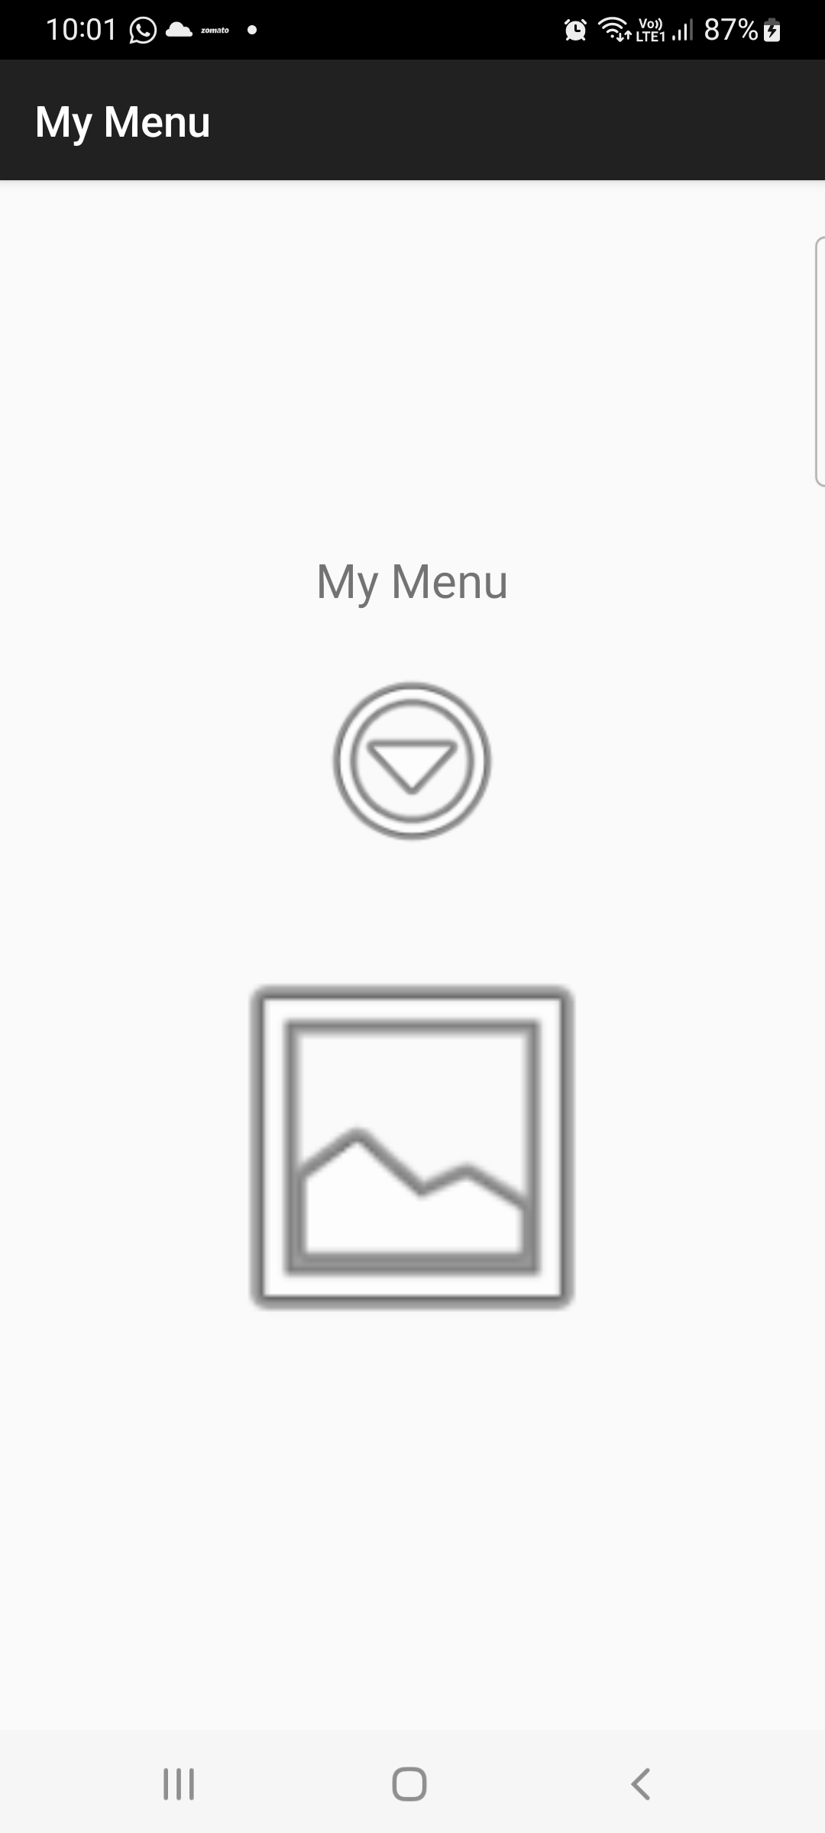
Q3. Create a view that displays textual content providing a description of "Digital Transformation". Add a filter option with submenus: a. "Search Keywords" - Allow the user to input keywords that can be searched within the content. b. "Highlight" - Highlight specific words or phrases provided by the user in the document. c. "Sort" - Provide an option to sort the entire content either alphabetically or by relevance to the search keywords.

AndroidManifest.xml:
<?xml version="1.0" encoding="utf-8"?>
<manifest xmlns:android="http://schemas.android.com/apk/res/android"
package="com.example.myapplication">
<application
android:allowBackup="true"
android:label="Digital Transformation"
android:theme="@style/Theme.AppCompat.Light.DarkActionBar">
<activity
android:name=".MainActivity"
android:exported="true">
<intent-filter>
<action android:name="android.intent.action.MAIN"/>
<category android:name="android.intent.category.LAUNCHER"/>
</intent-filter>
</activity>
</application>
</manifest>

MainActivity.java:
package com.example.myapplication;
import android.app.AlertDialog;
import android.os.Bundle;
import android.text.SpannableString;
import android.text.style.BackgroundColorSpan;
import android.view.Menu;
import android.view.MenuItem;
import android.widget.EditText;
import android.widget.TextView;
import android.widget.Toast;
import androidx.appcompat.app.AppCompatActivity;
import java.util.Arrays;
import java.util.Comparator;
public class MainActivity extends AppCompatActivity {
TextView textContent;
String originalText =
"Digital Transformation is the integration of digital technology into all areas of business. " +
"It changes how organizations operate and deliver value to customers. " +
"Technologies like AI, cloud computing, and big data drive innovation and efficiency.";
@Override
protected void onCreate(Bundle savedInstanceState) {
super.onCreate(savedInstanceState);
setContentView(R.layout.activity_main);
textContent = findViewById(R.id.textContent);
textContent.setText(originalText);
}
// Create Options Menu
@Override
public boolean onCreateOptionsMenu(Menu menu) {
getMenuInflater().inflate(R.menu.menu_filter, menu);
return true;
}
// Handle Menu Click
@Override
public boolean onOptionsItemSelected(MenuItem item) {
if (item.getItemId() == R.id.search) {
showSearchDialog();
return true;
}
if (item.getItemId() == R.id.highlight) {
showHighlightDialog();
return true;
}
if (item.getItemId() == R.id.sort_alpha) {
sortAlphabetically();
return true;
}
if (item.getItemId() == R.id.sort_relevance) {
sortByRelevance();
return true;
}
return super.onOptionsItemSelected(item);
}
// SEARCH
private void showSearchDialog() {
EditText input = new EditText(this);
new AlertDialog.Builder(this)
.setTitle("Enter Keyword")
.setView(input)
.setPositiveButton("Search", (dialog, which) -> {
String keyword = input.getText().toString();
if (originalText.toLowerCase().contains(keyword.toLowerCase())) {
Toast.makeText(this, "Keyword Found!", Toast.LENGTH_SHORT).show();
} else {
Toast.makeText(this, "Not Found", Toast.LENGTH_SHORT).show();
}
})
.setNegativeButton("Cancel", null)
.show();
}
// HIGHLIGHT
private void showHighlightDialog() {
EditText input = new EditText(this);
new AlertDialog.Builder(this)
.setTitle("Enter Word to Highlight")
.setView(input)
.setPositiveButton("Highlight", (dialog, which) -> {
String word = input.getText().toString();
SpannableString spannable =
new SpannableString(originalText);
int start = originalText.toLowerCase()
.indexOf(word.toLowerCase());
if (start >= 0) {
spannable.setSpan(
new BackgroundColorSpan(0xFFFFFF00),
start,
start + word.length(),
0);
textContent.setText(spannable);
}
})
.setNegativeButton("Cancel", null)
.show();
}
// SORT ALPHABETICALLY
private void sortAlphabetically() {
String[] words = originalText.split(" ");
Arrays.sort(words);
textContent.setText(String.join(" ", words));
}
// SORT BY RELEVANCE (based on word length)
private void sortByRelevance() {
String[] words = originalText.split(" ");
Arrays.sort(words, Comparator.comparingInt(String::length).reversed());
textContent.setText(String.join(" ", words));
}
}

activity_main.xml:
<?xml version="1.0" encoding="utf-8"?>
<LinearLayout xmlns:android="http://schemas.android.com/apk/res/android"
android:layout_width="match_parent"
android:layout_height="match_parent"
android:padding="16dp">
<ScrollView
android:layout_width="match_parent"
android:layout_height="match_parent">
<TextView
android:id="@+id/textContent"
android:layout_width="match_parent"
android:layout_height="wrap_content"
android:textSize="18sp"/>
</ScrollView>
</LinearLayout>

Res-> menu->menu_filter.xml:
<?xml version="1.0" encoding="utf-8"?>
<menu xmlns:android="http://schemas.android.com/apk/res/android">
<item
android:id="@+id/search"
android:title="Search Keywords"/>
<item
android:id="@+id/highlight"
android:title="Highlight"/>
<item
android:id="@+id/sort_alpha"
android:title="Sort Alphabetically"/>
<item
android:id="@+id/sort_relevance"
android:title="Sort by Relevance"/>
</menu>
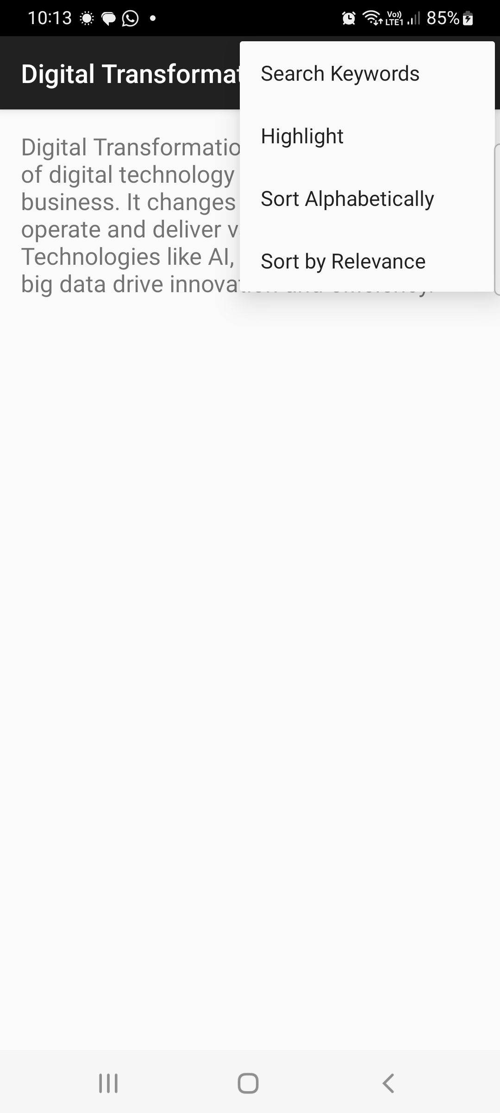

Extra Questions:
Q1.

CASE STUDY 1 – University Course Registration System
Design and develop a “University Course Registration” app where:
- Student enters Name and USN
- Selects Department (Spinner)
- Selects 3 subjects (Checkboxes)
- Selects Semester (Spinner)
- Selects Mode (ToggleButton: Online / Offline)
Rules:
- If Offline mode selected → Show Toast “Classroom Mode Selected”
- If no subject selected → Show error Toast
- On clicking Register → Open new screen displaying:
  - Name
  - USN
  - Department
  - Semester
  - Selected subjects
  - Mode
Reset button should clear all fields.
ANswer:

MainActivity.java

package com.example.myapplication;

import android.content.Intent;
import android.os.Bundle;
import android.widget.*;

import androidx.appcompat.app.AppCompatActivity;

public class MainActivity extends AppCompatActivity {

EditText editName, editUSN;
Spinner spinnerDept, spinnerSem;
CheckBox sub1, sub2, sub3;
ToggleButton toggleMode;
Button btnRegister, btnReset;

@Override
protected void onCreate(Bundle savedInstanceState) {
super.onCreate(savedInstanceState);
setContentView(R.layout.activity_main);

editName = findViewById(R.id.editName);
editUSN = findViewById(R.id.editUSN);
spinnerDept = findViewById(R.id.spinnerDept);
spinnerSem = findViewById(R.id.spinnerSem);
sub1 = findViewById(R.id.checkSub1);
sub2 = findViewById(R.id.checkSub2);
sub3 = findViewById(R.id.checkSub3);
toggleMode = findViewById(R.id.toggleMode);
btnRegister = findViewById(R.id.btnRegister);
btnReset = findViewById(R.id.btnReset);

// Spinner Data
String[] depts = {"ICT", "CSE", "ECE"};
String[] sems = {"Sem 1", "Sem 2", "Sem 3", "Sem 4"};

spinnerDept.setAdapter(new ArrayAdapter<>(this,
android.R.layout.simple_spinner_dropdown_item, depts));

spinnerSem.setAdapter(new ArrayAdapter<>(this,
android.R.layout.simple_spinner_dropdown_item, sems));

// Register Button
btnRegister.setOnClickListener(v -> {

String name = editName.getText().toString();
String usn = editUSN.getText().toString();

if(name.isEmpty() || usn.isEmpty()){
Toast.makeText(this, "Enter all details",
Toast.LENGTH_SHORT).show();
return;
}

if(!sub1.isChecked() && !sub2.isChecked() && !sub3.isChecked()){
Toast.makeText(this, "Select at least one subject",
Toast.LENGTH_SHORT).show();
return;
}

String subjects = "";
if(sub1.isChecked()) subjects += "Data Structures\n";
if(sub2.isChecked()) subjects += "Operating Systems\n";
if(sub3.isChecked()) subjects += "Database Management\n";

String dept = spinnerDept.getSelectedItem().toString();
String sem = spinnerSem.getSelectedItem().toString();
String mode = toggleMode.isChecked() ? "Offline" : "Online";

if(toggleMode.isChecked()){
Toast.makeText(this,
"Classroom Mode Selected",
Toast.LENGTH_SHORT).show();
}

Intent intent = new Intent(MainActivity.this, ResultActivity.class);
intent.putExtra("name", name);
intent.putExtra("usn", usn);
intent.putExtra("dept", dept);
intent.putExtra("sem", sem);
intent.putExtra("subjects", subjects);
intent.putExtra("mode", mode);

startActivity(intent);
});

// Reset Button
btnReset.setOnClickListener(v -> {
editName.setText("");
editUSN.setText("");
sub1.setChecked(false);
sub2.setChecked(false);
sub3.setChecked(false);
toggleMode.setChecked(false);
spinnerDept.setSelection(0);
spinnerSem.setSelection(0);
});
}
}

activity_main.xml
<?xml version="1.0" encoding="utf-8"?>

<ScrollView xmlns:android="http://schemas.android.com/apk/res/android"
android:layout_width="match_parent"
android:layout_height="match_parent"
android:padding="16dp">

<LinearLayout
android:orientation="vertical"
android:layout_width="match_parent"
android:layout_height="wrap_content">

<TextView
android:text="University Course Registration"
android:textSize="20sp"
android:textStyle="bold"
android:layout_marginBottom="20dp"
android:layout_width="wrap_content"
android:layout_height="wrap_content"/>

<EditText
android:id="@+id/editName"
android:hint="Enter Name"
android:layout_width="match_parent"
android:layout_height="wrap_content"/>

<EditText
android:id="@+id/editUSN"
android:hint="Enter USN"
android:layout_marginTop="10dp"
android:layout_width="match_parent"
android:layout_height="wrap_content"/>

<Spinner
android:id="@+id/spinnerDept"
android:layout_marginTop="10dp"
android:layout_width="match_parent"
android:layout_height="wrap_content"/>

<Spinner
android:id="@+id/spinnerSem"
android:layout_marginTop="10dp"
android:layout_width="match_parent"
android:layout_height="wrap_content"/>

<CheckBox
android:id="@+id/checkSub1"
android:text="Data Structures"
android:layout_marginTop="15dp"
android:layout_width="wrap_content"
android:layout_height="wrap_content"/>

<CheckBox
android:id="@+id/checkSub2"
android:text="Operating Systems"
android:layout_width="wrap_content"
android:layout_height="wrap_content"/>

<CheckBox
android:id="@+id/checkSub3"
android:text="Database Management"
android:layout_width="wrap_content"
android:layout_height="wrap_content"/>

<ToggleButton
android:id="@+id/toggleMode"
android:textOn="Offline"
android:textOff="Online"
android:layout_marginTop="15dp"
android:layout_width="match_parent"
android:layout_height="wrap_content"/>

<Button
android:id="@+id/btnRegister"
android:text="Register"
android:layout_marginTop="20dp"
android:layout_width="match_parent"
android:layout_height="wrap_content"/>

<Button
android:id="@+id/btnReset"
android:text="Reset"
android:layout_marginTop="10dp"
android:layout_width="match_parent"
android:layout_height="wrap_content"/>

</LinearLayout>
</ScrollView>

activity_result.xml

<?xml version="1.0" encoding="utf-8"?>

<LinearLayout xmlns:android="http://schemas.android.com/apk/res/android"
android:orientation="vertical"
android:padding="20dp"
android:layout_width="match_parent"
android:layout_height="match_parent">

<TextView
android:id="@+id/textResult"
android:textSize="18sp"
android:layout_width="match_parent"
android:layout_height="wrap_content"/>

</LinearLayout>

ResultActivity.java

package com.example.myapplication;

import android.os.Bundle;
import android.widget.TextView;
import androidx.appcompat.app.AppCompatActivity;

public class ResultActivity extends AppCompatActivity {

@Override
protected void onCreate(Bundle savedInstanceState) {
super.onCreate(savedInstanceState);
setContentView(R.layout.activity_result);

TextView text = findViewById(R.id.textResult);

String details =
"Name: " + getIntent().getStringExtra("name") + "\n\n" +
"USN: " + getIntent().getStringExtra("usn") + "\n\n" +
"Department: " + getIntent().getStringExtra("dept") + "\n\n" +
"Semester: " + getIntent().getStringExtra("sem") + "\n\n" +
"Subjects:\n" + getIntent().getStringExtra("subjects") + "\n" +
"Mode: " + getIntent().getStringExtra("mode");

text.setText(details);
}
}

Androidmanifest.xml
<?xml version="1.0" encoding="utf-8"?>
<manifest xmlns:android="http://schemas.android.com/apk/res/android"
package="com.example.myapplication">
<application
android:allowBackup="true"
android:label="University Course Registration System"
android:theme="@style/Theme.AppCompat.Light.DarkActionBar">
<activity android:name=".RegisterActivity"/>
<activity
android:name=".MainActivity"
android:exported="true">
<!-- This makes it the launcher activity -->
<intent-filter>
<action android:name="android.intent.action.MAIN" />
<category android:name="android.intent.category.LAUNCHER" />
</intent-filter>
</activity>
</application>
</manifest>

CASE STUDY 1 (20 Marks)

🏋 Smart Fitness Planner App
Design and develop an application called “Smart Fitness Planner” with the following requirements:

🔹 Home Screen:
- Display workout categories in a GridView with images and names
  - Weight Loss
  - Muscle Gain
  - Cardio
  - Yoga
- When a grid item is clicked:
  - Show a custom Toast with image + text
  - Navigate to Workout Details screen

🔹 Workout Details Screen:
Include:
- Spinner → Select Trainer
- DatePicker → Select Start Date
- TimePicker → Select Session Time
- ToggleButton → Beginner / Advanced
- Submit Button
- Reset Button

🔹 Logic:
- If “Advanced” is selected → Submit button enabled only after 6:00 AM
- Validate all inputs
- On Submit → Show Booking Summary screen

🔹 Summary Screen:
Display:
- Workout Type
- Trainer
- Date
- Time
- Level
- Random Batch ID
Use:
- ScrollView
- ImageView (workout image)
- Proper formatted layout

AndroidManifest.xml
<?xml version="1.0" encoding="utf-8"?>
<manifest xmlns:android="http://schemas.android.com/apk/res/android"
package="com.example.smartfitness">

<application
android:allowBackup="true"
android:label="Smart Fitness Planner"
android:theme="@style/Theme.AppCompat.Light.DarkActionBar">

<activity android:name=".SummaryActivity"/>
<activity android:name=".WorkoutDetailsActivity"/>
<activity android:name=".MainActivity"
android:exported="true">

<intent-filter>
<action android:name="android.intent.action.MAIN"/>
<category android:name="android.intent.category.LAUNCHER"/>
</intent-filter>
</activity>

</application>
</manifest>
activity_main.xml (Home Screen)

<GridView
xmlns:android="http://schemas.android.com/apk/res/android"
android:id="@+id/gridView"
android:layout_width="match_parent"
android:layout_height="match_parent"
android:numColumns="2"
android:verticalSpacing="16dp"
android:horizontalSpacing="16dp"
android:padding="16dp"/>

grid_item.xml
<LinearLayout xmlns:android="http://schemas.android.com/apk/res/android"
android:layout_width="match_parent"
android:layout_height="wrap_content"
android:orientation="vertical"
android:gravity="center">

<ImageView
android:id="@+id/gridImage"
android:layout_width="100dp"
android:layout_height="100dp"/>

<TextView
android:id="@+id/gridText"
android:layout_width="wrap_content"
android:layout_height="wrap_content"
android:textSize="16sp"/>
</LinearLayout>

toast_custom.xml
<LinearLayout xmlns:android="http://schemas.android.com/apk/res/android"
android:orientation="horizontal"
android:padding="8dp"
android:background="#DDDDDD">

<ImageView
android:id="@+id/toastImage"
android:layout_width="40dp"
android:layout_height="40dp"
android:src="@drawable/toast_icon"/>

<TextView
android:id="@+id/toastText"
android:layout_marginStart="10dp"
android:textSize="16sp"
android:layout_width="wrap_content"
android:layout_height="wrap_content"/>
</LinearLayout>
MainActivity.java
package com.example.smartfitness;

import android.content.Intent;
import android.os.Bundle;
import android.view.LayoutInflater;
import android.view.View;
import android.widget.*;

import androidx.appcompat.app.AppCompatActivity;

public class MainActivity extends AppCompatActivity {

String[] workouts = {"Weight Loss","Muscle Gain","Cardio","Yoga"};
int[] images = {R.drawable.weight_loss,
R.drawable.muscle_gain,
R.drawable.cardio,
R.drawable.yoga};

@Override
protected void onCreate(Bundle savedInstanceState) {
super.onCreate(savedInstanceState);
setContentView(R.layout.activity_main);

GridView gridView = findViewById(R.id.gridView);

BaseAdapter adapter = new BaseAdapter() {
@Override
public int getCount() { return workouts.length; }

@Override
public Object getItem(int i) { return workouts[i]; }

@Override
public long getItemId(int i) { return i; }

@Override
public View getView(int i, View view, ViewGroup parent) {

view = LayoutInflater.from(MainActivity.this)
.inflate(R.layout.grid_item, parent, false);

ImageView img = view.findViewById(R.id.gridImage);
TextView txt = view.findViewById(R.id.gridText);

img.setImageResource(images[i]);
txt.setText(workouts[i]);

return view;
}
};

gridView.setAdapter(adapter);

gridView.setOnItemClickListener((parent, view, position, id) -> {

showCustomToast(workouts[position]);

Intent intent = new Intent(this, WorkoutDetailsActivity.class);
intent.putExtra("Workout", workouts[position]);
intent.putExtra("Image", images[position]);
startActivity(intent);
});
}

private void showCustomToast(String text){
View layout = getLayoutInflater().inflate(R.layout.toast_custom, null);

TextView txt = layout.findViewById(R.id.toastText);
txt.setText(text + " Selected!");

Toast toast = new Toast(this);
toast.setView(layout);
toast.setDuration(Toast.LENGTH_SHORT);
toast.show();
}
}

activity_workout_details.xml
<ScrollView xmlns:android="http://schemas.android.com/apk/res/android"
android:padding="16dp"
android:layout_width="match_parent"
android:layout_height="match_parent">

<LinearLayout
android:orientation="vertical"
android:layout_width="match_parent"
android:layout_height="wrap_content">

<Spinner
android:id="@+id/spinnerTrainer"
android:layout_width="match_parent"
android:layout_height="wrap_content"/>

<DatePicker
android:id="@+id/datePicker"
android:layout_width="match_parent"
android:layout_height="wrap_content"/>

<TimePicker
android:id="@+id/timePicker"
android:layout_width="match_parent"
android:layout_height="wrap_content"/>

<ToggleButton
android:id="@+id/toggleLevel"
android:textOn="Advanced"
android:textOff="Beginner"
android:layout_width="wrap_content"
android:layout_height="wrap_content"/>

<Button
android:id="@+id/btnSubmit"
android:text="Submit"
android:layout_width="match_parent"
android:layout_height="wrap_content"/>

<Button
android:id="@+id/btnReset"
android:text="Reset"
android:layout_width="match_parent"
android:layout_height="wrap_content"/>
</LinearLayout>
</ScrollView>

WorkoutDetailsActivity.java

package com.example.smartfitness;

import android.content.Intent;
import android.os.Bundle;
import android.widget.*;

import androidx.appcompat.app.AppCompatActivity;

import java.util.Random;

public class WorkoutDetailsActivity extends AppCompatActivity {

@Override
protected void onCreate(Bundle savedInstanceState) {
super.onCreate(savedInstanceState);
setContentView(R.layout.activity_workout_details);

Spinner spinner = findViewById(R.id.spinnerTrainer);
DatePicker datePicker = findViewById(R.id.datePicker);
TimePicker timePicker = findViewById(R.id.timePicker);
ToggleButton toggle = findViewById(R.id.toggleLevel);
Button submit = findViewById(R.id.btnSubmit);
Button reset = findViewById(R.id.btnReset);

String workout = getIntent().getStringExtra("Workout");
int image = getIntent().getIntExtra("Image",0);

String[] trainers = {"Trainer A","Trainer B","Trainer C"};
spinner.setAdapter(new ArrayAdapter<>(this,
android.R.layout.simple_spinner_dropdown_item, trainers));

submit.setOnClickListener(v -> {

int hour = timePicker.getHour();

if(toggle.isChecked() && hour < 6){
Toast.makeText(this,
"Advanced allowed only after 6 AM",
Toast.LENGTH_SHORT).show();
return;
}

String trainer = spinner.getSelectedItem().toString();
String date = datePicker.getDayOfMonth() + "/" +
(datePicker.getMonth()+1) + "/" +
datePicker.getYear();

String time = hour + ":" + timePicker.getMinute();
String level = toggle.isChecked() ? "Advanced" : "Beginner";

int batchId = new Random().nextInt(9000) + 1000;

Intent intent = new Intent(this, SummaryActivity.class);
intent.putExtra("Workout", workout);
intent.putExtra("Trainer", trainer);
intent.putExtra("Date", date);
intent.putExtra("Time", time);
intent.putExtra("Level", level);
intent.putExtra("Batch", batchId);
intent.putExtra("Image", image);

startActivity(intent);
});

reset.setOnClickListener(v -> {
spinner.setSelection(0);
toggle.setChecked(false);
});
}
}
activity_summary.xml
<ScrollView xmlns:android="http://schemas.android.com/apk/res/android"
android:padding="16dp"
android:layout_width="match_parent"
android:layout_height="match_parent">

<LinearLayout
android:orientation="vertical"
android:layout_width="match_parent"
android:layout_height="wrap_content">

<ImageView
android:id="@+id/summaryImage"
android:layout_width="150dp"
android:layout_height="150dp"
android:layout_gravity="center"/>

<TextView
android:id="@+id/summaryText"
android:textSize="18sp"
android:layout_width="match_parent"
android:layout_height="wrap_content"/>
</LinearLayout>
</ScrollView>

SummaryActivity.java
package com.example.smartfitness;

import android.os.Bundle;
import android.widget.ImageView;
import android.widget.TextView;

import androidx.appcompat.app.AppCompatActivity;

public class SummaryActivity extends AppCompatActivity {

@Override
protected void onCreate(Bundle savedInstanceState) {
super.onCreate(savedInstanceState);
setContentView(R.layout.activity_summary);

ImageView img = findViewById(R.id.summaryImage);
TextView txt = findViewById(R.id.summaryText);

img.setImageResource(getIntent().getIntExtra("Image",0));

String details =
"Workout: " + getIntent().getStringExtra("Workout") +
"\nTrainer: " + getIntent().getStringExtra("Trainer") +
"\nDate: " + getIntent().getStringExtra("Date") +
"\nTime: " + getIntent().getStringExtra("Time") +
"\nLevel: " + getIntent().getStringExtra("Level") +
"\nBatch ID: " + getIntent().getIntExtra("Batch",0);

txt.setText(details);
}
}

CASE STUDY 3 (20 Marks)

🛒 Smart Shopping Mart
Develop an app called “Smart Shopping Mart”

🔹 Main Screen:
Display products using GridView with product images
Example:
- Shoes
- Watch
- Bag
- Phone
On clicking product:
- Show custom Toast with product image
- Add to Cart

🔹 Cart Screen:
- ListView of selected products
- Spinner → Payment Mode (UPI / Card / Cash)
- ToggleButton → Express Delivery
- DatePicker → Delivery Date
- Button → Place Order

🔹 Conditions:
- If Express selected → Only future dates allowed
- Show AlertDialog confirmation before order

🔹 Final Screen:
Display:
- Product images
- Total amount
- Delivery date
- Payment method
- Unique Order ID

📁 REQUIRED FILES

Java Files
MainActivity.java
CartActivity.java
FinalActivity.java

XML Files
activity_main.xml
activity_cart.xml
activity_final.xml
grid_item.xml
toast_custom.xml

Drawable Images (Put inside res/drawable)
Rename properly:
Shoes.png
Watch.png
bag.png
phone.png

cart_icon.png

AndroidManifest.xml
<manifest xmlns:android="http://schemas.android.com/apk/res/android"
package="com.example.smartshopping">

<application
android:allowBackup="true"
android:label="Smart Shopping Mart"
android:theme="@style/Theme.AppCompat.Light.DarkActionBar">

<activity android:name=".FinalActivity"/>
<activity android:name=".CartActivity"/>
<activity android:name=".MainActivity"
android:exported="true">

<intent-filter>
<action android:name="android.intent.action.MAIN"/>
<category android:name="android.intent.category.LAUNCHER"/>
</intent-filter>

</activity>
</application>
</manifest>
activity_main.xml (Product Grid)
<GridView xmlns:android="http://schemas.android.com/apk/res/android"
android:id="@+id/gridView"
android:layout_width="match_parent"
android:layout_height="match_parent"
android:numColumns="2"
android:padding="16dp"
android:verticalSpacing="16dp"
android:horizontalSpacing="16dp"/>

<GridView xmlns:android="http://schemas.android.com/apk/res/android"
android:id="@+id/gridView"
android:layout_width="match_parent"
android:layout_height="match_parent"
android:numColumns="2"
android:padding="16dp"
android:verticalSpacing="16dp"
android:horizontalSpacing="16dp"/>

grid_item.xml
<LinearLayout xmlns:android="http://schemas.android.com/apk/res/android"
android:orientation="vertical"
android:gravity="center"
android:layout_width="match_parent"
android:layout_height="wrap_content">

<ImageView
android:id="@+id/productImage"
android:layout_width="100dp"
android:layout_height="100dp"/>

<TextView
android:id="@+id/productName"
android:textSize="16sp"
android:layout_width="wrap_content"
android:layout_height="wrap_content"/>
</LinearLayout>

toast_custom.xml
<LinearLayout xmlns:android="http://schemas.android.com/apk/res/android"
android:orientation="horizontal"
android:padding="8dp"
android:background="#EEEEEE">

<ImageView
android:id="@+id/toastImage"
android:layout_width="40dp"
android:layout_height="40dp"/>

<TextView
android:id="@+id/toastText"
android:layout_marginStart="10dp"
android:textSize="16sp"
android:layout_width="wrap_content"
android:layout_height="wrap_content"/>
</LinearLayout>

MainActivity.java (Grid + Add to Cart)

package com.example.smartshopping;

import android.content.Intent;
import android.os.Bundle;
import android.view.LayoutInflater;
import android.view.View;
import android.widget.*;

import androidx.appcompat.app.AppCompatActivity;

import java.util.ArrayList;

public class MainActivity extends AppCompatActivity {

static ArrayList<String> cart = new ArrayList<>();
static ArrayList<Integer> prices = new ArrayList<>();

String[] products = {"Shoes","Watch","Bag","Phone"};
int[] images = {R.drawable.shoes,
R.drawable.watch,
R.drawable.bag,
R.drawable.phone};

int[] productPrices = {2000,1500,1200,10000};

@Override
protected void onCreate(Bundle savedInstanceState) {
super.onCreate(savedInstanceState);
setContentView(R.layout.activity_main);

GridView grid = findViewById(R.id.gridView);

BaseAdapter adapter = new BaseAdapter() {
public int getCount() { return products.length; }
public Object getItem(int i) { return products[i]; }
public long getItemId(int i) { return i; }

public View getView(int i, View view, ViewGroup parent) {
view = LayoutInflater.from(MainActivity.this)
.inflate(R.layout.grid_item,parent,false);

ImageView img = view.findViewById(R.id.productImage);
TextView txt = view.findViewById(R.id.productName);

img.setImageResource(images[i]);
txt.setText(products[i]);

return view;
}
};

grid.setAdapter(adapter);

grid.setOnItemClickListener((parent, view, position, id) -> {

cart.add(products[position]);
prices.add(productPrices[position]);

showToast(products[position], images[position]);

Intent intent = new Intent(this, CartActivity.class);
startActivity(intent);
});
}

private void showToast(String name, int imgRes){
View layout = getLayoutInflater().inflate(R.layout.toast_custom,null);

ImageView img = layout.findViewById(R.id.toastImage);
TextView txt = layout.findViewById(R.id.toastText);

img.setImageResource(imgRes);
txt.setText(name + " added to cart!");

Toast t = new Toast(this);
t.setView(layout);
t.setDuration(Toast.LENGTH_SHORT);
t.show();
}
}

activity_cart.xml
<ScrollView xmlns:android="http://schemas.android.com/apk/res/android"
android:padding="16dp"
android:layout_width="match_parent"
android:layout_height="match_parent">

<LinearLayout
android:orientation="vertical"
android:layout_width="match_parent"
android:layout_height="wrap_content">

<ListView
android:id="@+id/listCart"
android:layout_width="match_parent"
android:layout_height="200dp"/>

<Spinner
android:id="@+id/spinnerPayment"
android:layout_width="match_parent"
android:layout_height="wrap_content"/>

<ToggleButton
android:id="@+id/toggleExpress"
android:textOn="Express Delivery"
android:textOff="Normal Delivery"
android:layout_width="match_parent"
android:layout_height="wrap_content"/>

<DatePicker
android:id="@+id/datePicker"
android:layout_width="match_parent"
android:layout_height="wrap_content"/>

<Button
android:id="@+id/btnOrder"
android:text="Place Order"
android:layout_width="match_parent"
android:layout_height="wrap_content"/>

</LinearLayout>
</ScrollView>

CartActivity.java
package com.example.smartshopping;

import android.app.AlertDialog;
import android.content.Intent;
import android.os.Bundle;
import android.widget.*;

import androidx.appcompat.app.AppCompatActivity;

import java.util.Calendar;
import java.util.Random;

public class CartActivity extends AppCompatActivity {

@Override
protected void onCreate(Bundle savedInstanceState) {
super.onCreate(savedInstanceState);
setContentView(R.layout.activity_cart);

ListView list = findViewById(R.id.listCart);
Spinner spinner = findViewById(R.id.spinnerPayment);
ToggleButton toggle = findViewById(R.id.toggleExpress);
DatePicker datePicker = findViewById(R.id.datePicker);
Button btnOrder = findViewById(R.id.btnOrder);

list.setAdapter(new ArrayAdapter<>(this,
android.R.layout.simple_list_item_1,
MainActivity.cart));

String[] modes = {"UPI","Card","Cash"};
spinner.setAdapter(new ArrayAdapter<>(this,
android.R.layout.simple_spinner_dropdown_item,modes));

btnOrder.setOnClickListener(v -> {

if(toggle.isChecked()){
Calendar today = Calendar.getInstance();
Calendar selected = Calendar.getInstance();
selected.set(datePicker.getYear(),
datePicker.getMonth(),
datePicker.getDayOfMonth());

if(!selected.after(today)){
Toast.makeText(this,
"Express requires future date",
Toast.LENGTH_SHORT).show();
return;
}
}

new AlertDialog.Builder(this)
.setTitle("Confirm Order")
.setMessage("Are you sure?")
.setPositiveButton("Yes",(d,i)->{

int total = 0;
for(int p: MainActivity.prices)
total += p;

String date = datePicker.getDayOfMonth()+"/"+
(datePicker.getMonth()+1)+"/"+
datePicker.getYear();

String payment = spinner.getSelectedItem().toString();
int orderId = new Random().nextInt(90000)+10000;

Intent intent = new Intent(this, FinalActivity.class);
intent.putExtra("Total",total);
intent.putExtra("Date",date);
intent.putExtra("Payment",payment);
intent.putExtra("OrderID",orderId);
startActivity(intent);

})
.setNegativeButton("No",null)
.show();
});
}
}

activity_final.xml
<ScrollView xmlns:android="http://schemas.android.com/apk/res/android"
android:padding="16dp"
android:layout_width="match_parent"
android:layout_height="match_parent">

<LinearLayout
android:orientation="vertical"
android:layout_width="match_parent"
android:layout_height="wrap_content">

<TextView
android:id="@+id/finalText"
android:textSize="18sp"
android:layout_width="match_parent"
android:layout_height="wrap_content"/>

</LinearLayout>
</ScrollView>

FinalActivity.java

package com.example.smartshopping;

import android.os.Bundle;
import android.widget.TextView;

import androidx.appcompat.app.AppCompatActivity;

public class FinalActivity extends AppCompatActivity {

@Override
protected void onCreate(Bundle savedInstanceState) {
super.onCreate(savedInstanceState);
setContentView(R.layout.activity_final);

TextView txt = findViewById(R.id.finalText);

txt.setText("Total Amount: ₹"+
getIntent().getIntExtra("Total",0)
+"\nDelivery Date: "+
getIntent().getStringExtra("Date")
+"\nPayment Mode: "+
getIntent().getStringExtra("Payment")
+"\nOrder ID: "+
getIntent().getIntExtra("OrderID",0));
}
}

CASE STUDY 1 (20 Marks)

🎓 “Campus Event Management System”
Develop an application for managing college events.

🔹 Home Screen:
- Display event categories using GridView with images
  - Technical
  - Cultural
  - Sports
  - Workshops
- On clicking category:
  - Show Custom Toast with image
  - Open Event Registration screen

🔹 Event Registration Screen:
Include:
- EditText → Student Name
- Spinner → Event Name
- DatePicker → Event Date
- TimePicker → Event Time
- ToggleButton → Solo / Team
- Button → Register

🔹 Menu (Options Menu):
Add menu items:
- About
- Contact
- Exit
On clicking:
- About → Show AlertDialog
- Contact → Show Toast
- Exit → Close app

🔹 Context Menu:
On long-press of event name:
- View Details
- Cancel Registration

🔹 Summary Screen:
Show:
- Event image
- Student name
- Event name
- Date
- Time
- Participation type
- Unique Registration ID

Answer)

REQUIRED FILES

Java Files
MainActivity.java
RegistrationActivity.java
SummaryActivity.java

XML Files
activity_main.xml
grid_item.xml
toast_custom.xml
activity_registration.xml
activity_summary.xml
menu_main.xml
context_menu.xml

Drawable Images (Put in res/drawable)
Technical.png
Cultural.png
sports.png
workshop.png

toast_icon.png

🟢 1️⃣ AndroidManifest.xml
<manifest xmlns:android="http://schemas.android.com/apk/res/android"
package="com.example.campusevent">
<application
android:allowBackup="true"
android:label="Campus Event Management"
android:theme="@style/Theme.AppCompat.Light.DarkActionBar">
<activity android:name=".SummaryActivity"/>
<activity android:name=".RegistrationActivity"/>
<activity android:name=".MainActivity"
android:exported="true">
<intent-filter>
<action android:name="android.intent.action.MAIN"/>
<category android:name="android.intent.category.LAUNCHER"/>
</intent-filter>
</activity>
</application>
</manifest>

🟢 2️⃣ activity_main.xml (GridView Home)
<GridView xmlns:android="http://schemas.android.com/apk/res/android"
android:id="@+id/gridView"
android:layout_width="match_parent"
android:layout_height="match_parent"
android:numColumns="2"
android:padding="16dp"
android:verticalSpacing="16dp"
android:horizontalSpacing="16dp"/>

🟢 3️⃣ grid_item.xml
<LinearLayout xmlns:android="http://schemas.android.com/apk/res/android"
android:orientation="vertical"
android:gravity="center"
android:layout_width="match_parent"
android:layout_height="wrap_content">
<ImageView
android:id="@+id/gridImage"
android:layout_width="100dp"
android:layout_height="100dp"/>
<TextView
android:id="@+id/gridText"
android:textSize="16sp"
android:layout_width="wrap_content"
android:layout_height="wrap_content"/>
</LinearLayout>

🟢 4️⃣ toast_custom.xml
<LinearLayout xmlns:android="http://schemas.android.com/apk/res/android"
android:orientation="horizontal"
android:padding="8dp"
android:background="#EEEEEE">
<ImageView
android:id="@+id/toastImage"
android:layout_width="40dp"
android:layout_height="40dp"
android:src="@drawable/toast_icon"/>
<TextView
android:id="@+id/toastText"
android:layout_marginStart="10dp"
android:textSize="16sp"
android:layout_width="wrap_content"
android:layout_height="wrap_content"/>
</LinearLayout>

🟢 5️⃣ MainActivity.java (Grid + Custom Toast)
package com.example.campusevent;
import android.content.Intent;
import android.os.Bundle;
import android.view.LayoutInflater;
import android.view.View;
import android.widget.*;
import androidx.appcompat.app.AppCompatActivity;
public class MainActivity extends AppCompatActivity {
String[] categories = {"Technical","Cultural","Sports","Workshops"};
int[] images = {R.drawable.technical,
R.drawable.cultural,R.drawable.sports,
R.drawable.workshop};
@Override
protected void onCreate(Bundle savedInstanceState) {
super.onCreate(savedInstanceState);
setContentView(R.layout.activity_main);
GridView grid = findViewById(R.id.gridView);
BaseAdapter adapter = new BaseAdapter() {
public int getCount(){ return categories.length; }
public Object getItem(int i){ return categories[i]; }
public long getItemId(int i){ return i; }
public View getView(int i, View view, ViewGroup parent){
view = LayoutInflater.from(MainActivity.this)
.inflate(R.layout.grid_item,parent,false);
ImageView img = view.findViewById(R.id.gridImage);
TextView txt = view.findViewById(R.id.gridText);
img.setImageResource(images[i]);
txt.setText(categories[i]);
return view;
}
};
grid.setAdapter(adapter);
grid.setOnItemClickListener((parent, view, position, id)->{
showToast(categories[position],images[position]);
Intent intent = new Intent(this, RegistrationActivity.class);
intent.putExtra("Category",categories[position]);
intent.putExtra("Image",images[position]);
startActivity(intent);
});
}
private void showToast(String text,int imgRes){
View layout = getLayoutInflater().inflate(R.layout.toast_custom,null);
ImageView img = layout.findViewById(R.id.toastImage);
TextView txt = layout.findViewById(R.id.toastText);
img.setImageResource(imgRes);
txt.setText(text + " Selected");
Toast t = new Toast(this);
t.setView(layout);
t.setDuration(Toast.LENGTH_SHORT);
t.show();
}
}🟢 6️⃣ activity_registration.xml:<ScrollView xmlns:android="http://schemas.android.com/apk/res/android"
android:padding="16dp"
android:layout_width="match_parent"
android:layout_height="match_parent">
<LinearLayout
android:orientation="vertical"
android:layout_width="match_parent"
android:layout_height="wrap_content">
<EditText
android:id="@+id/editName"
android:hint="Enter Student Name"
android:layout_width="match_parent"
android:layout_height="wrap_content"/>
<Spinner
android:id="@+id/spinnerEvent"
android:layout_width="match_parent"
android:layout_height="wrap_content"/>
<DatePicker
android:id="@+id/datePicker"
android:layout_width="match_parent"
android:layout_height="wrap_content"/>
<TimePicker
android:id="@+id/timePicker"
android:layout_width="match_parent"
android:layout_height="wrap_content"/>
<ToggleButton
android:id="@+id/toggleType"
android:textOn="Team"
android:textOff="Solo"
android:layout_width="wrap_content"
android:layout_height="wrap_content"/>
<Button
android:id="@+id/btnRegister"
android:text="Register"
android:layout_width="match_parent"
android:layout_height="wrap_content"/>
</LinearLayout>
</ScrollView>

🟢 7️⃣ Options Menu XML (res/menu/menu_main.xml)
<menu xmlns:android="http://schemas.android.com/apk/res/android">
<item android:id="@+id/menuAbout"
android:title="About"/>
<item android:id="@+id/menuContact"
android:title="Contact"/>
<item android:id="@+id/menuExit"
android:title="Exit"/>
</menu>

🟢 8️⃣ Context Menu XML (res/menu/context_menu.xml)
<menu xmlns:android="http://schemas.android.com/apk/res/android">
<item android:id="@+id/viewDetails"
android:title="View Details"/>
<item android:id="@+id/cancelReg"
android:title="Cancel Registration"/>
</menu>

🟢 9️⃣ RegistrationActivity.java
package com.example.campusevent;
import android.app.AlertDialog;
import android.content.Intent;
import android.os.Bundle;
import android.view.ContextMenu;
import android.view.Menu;
import android.view.MenuInflater;
import android.view.MenuItem;
import android.view.View;
import android.widget.*;
import androidx.appcompat.app.AppCompatActivity;
import java.util.Random;
public class RegistrationActivity extends AppCompatActivity {
Spinner spinner;
EditText editName;
ToggleButton toggle;
DatePicker datePicker;
TimePicker timePicker;
String category;
int image;
@Override
protected void onCreate(Bundle savedInstanceState) {
super.onCreate(savedInstanceState);
setContentView(R.layout.activity_registration);
category = getIntent().getStringExtra("Category");
image = getIntent().getIntExtra("Image",0);
spinner = findViewById(R.id.spinnerEvent);
editName = findViewById(R.id.editName);
toggle = findViewById(R.id.toggleType);
datePicker = findViewById(R.id.datePicker);
timePicker = findViewById(R.id.timePicker);
Button btn = findViewById(R.id.btnRegister);
String[] events = {"Coding Contest","Dance","Football","AI Workshop"};
spinner.setAdapter(new ArrayAdapter<>(this,
android.R.layout.simple_spinner_dropdown_item,events));
registerForContextMenu(spinner);
btn.setOnClickListener(v -> {
if(editName.getText().toString().isEmpty()){
Toast.makeText(this,"Enter Name",Toast.LENGTH_SHORT).show();
return;
}
String date = datePicker.getDayOfMonth()+"/"+
(datePicker.getMonth()+1)+"/"+
datePicker.getYear();
String time = timePicker.getHour()+":"+
timePicker.getMinute();
String type = toggle.isChecked() ? "Team" : "Solo";
int id = new Random().nextInt(9000)+1000;
Intent intent = new Intent(this, SummaryActivity.class);
intent.putExtra("Name",editName.getText().toString());
intent.putExtra("Event",spinner.getSelectedItem().toString());
intent.putExtra("Date",date);
intent.putExtra("Time",time);
intent.putExtra("Type",type);
intent.putExtra("ID",id);
intent.putExtra("Image",image);
startActivity(intent);
});
}
// Options Menu
public boolean onCreateOptionsMenu(Menu menu){
MenuInflater inflater = getMenuInflater();
inflater.inflate(R.menu.menu_main,menu);
return true;
}
public boolean onOptionsItemSelected(MenuItem item){
if(item.getItemId()==R.id.menuAbout){
new AlertDialog.Builder(this)
.setTitle("About")
.setMessage("Campus Event Management App")
.setPositiveButton("OK",null)
.show();
} else if(item.getItemId()==R.id.menuContact){
Toast.makeText(this,"Contact: 9876543210",Toast.LENGTH_SHORT).show();
} else if(item.getItemId()==R.id.menuExit){
finishAffinity();
}
return true;
}
// Context Menu
public void onCreateContextMenu(ContextMenu menu, View v,
ContextMenu.ContextMenuInfo menuInfo){
getMenuInflater().inflate(R.menu.context_menu,menu);
}
public boolean onContextItemSelected(MenuItem item){
if(item.getItemId()==R.id.viewDetails){
Toast.makeText(this,"Viewing Details",Toast.LENGTH_SHORT).show();
} else if(item.getItemId()==R.id.cancelReg){
Toast.makeText(this,"Registration Cancelled",Toast.LENGTH_SHORT).show();
}
return true;
}
}

🟢 🔟 SummaryActivity.java
package com.example.campusevent;
import android.os.Bundle;
import android.widget.ImageView;
import android.widget.TextView;
import androidx.appcompat.app.AppCompatActivity;
public class SummaryActivity extends AppCompatActivity {
@Override
protected void onCreate(Bundle savedInstanceState) {
super.onCreate(savedInstanceState);
setContentView(R.layout.activity_summary);
ImageView img = findViewById(R.id.summaryImage);
TextView txt = findViewById(R.id.summaryText);
img.setImageResource(getIntent().getIntExtra("Image",0));
txt.setText("Name: "+getIntent().getStringExtra("Name")
+"\nEvent: "+getIntent().getStringExtra("Event")
+"\nDate: "+getIntent().getStringExtra("Date")
+"\nTime: "+getIntent().getStringExtra("Time")
+"\nType: "+getIntent().getStringExtra("Type")
+"\nRegistration ID: "+getIntent().getIntExtra("ID",0));
}
}

🟢 activity_summary.xml
<ScrollView xmlns:android="http://schemas.android.com/apk/res/android"
android:padding="16dp"
android:layout_width="match_parent"
android:layout_height="match_parent">
<LinearLayout
android:orientation="vertical"
android:layout_width="match_parent"
android:layout_height="wrap_content">
<ImageView
android:id="@+id/summaryImage"
android:layout_width="150dp"
android:layout_height="150dp"
android:layout_gravity="center"/>
<TextView
android:id="@+id/summaryText"
android:textSize="18sp"
android:layout_width="match_parent"
android:layout_height="wrap_content"/>
</LinearLayout>
</ScrollView>

Campus Fest Management System – Pro Version”

🟢 OVERVIEW
Create an app called:

📌 “Campus Fest Pro”
It manages registrations for a college fest.

🔹 MAIN SCREEN (With Tabs)
Use TabLayout + ViewPager.
Create 3 Tabs:

🟡 Tab 1: Events
- Display categories using GridView
  - Technical
  - Cultural
  - Gaming
  - Workshops
On clicking:
- Show Custom Toast (with image)
- Open Registration Activity

🟡 Tab 2: Schedule
- Show ListView of event schedule
- Long press → Context Menu:
  - View Details
  - Add Reminder

🟡 Tab 3: Profile
- EditText → Name
- Spinner → Department
- ToggleButton → Volunteer / Participant
- Button → Save
Show PopupMenu on 3-dot button:
- Edit
- Logout

🔹 REGISTRATION SCREEN
When event selected:
Include:
- Spinner → Event Name
- DatePicker
- TimePicker
- ToggleButton → Solo / Team
- Button → Register

🔹 LOGIC CONDITIONS
1️⃣ If Team selected → Registration allowed only after 9AM
2️⃣ No past dates allowed
3️⃣ If Volunteer selected in Profile → 50% discount
4️⃣ Show AlertDialog confirmation before register

🔹 OPTIONS MENU (Top Right)
Add:
- About
- Contact
- Exit

🔹 SUMMARY SCREEN
Display:
- Event Image
- Student Name
- Event
- Date
- Time
- Type
- Discount
- Unique Registration ID
Use:
- ScrollView
- ImageView
- Proper formatting

We will build:
MainActivity (TabLayout + ViewPager)
Fragments:
EventsFragment
ScheduleFragment
ProfileFragment
Activities:
RegistrationActivity
SummaryActivity
Layouts:
activity_main.xml
fragment_events.xml
fragment_schedule.xml
fragment_profile.xml
activity_registration.xml
activity_summary.xml
grid_item.xml
toast_custom.xml
Menus:
menu_options.xml
menu_popup.xml
context_menu.xml
Drawable images required:
technical.png
cultural.png
gaming.png
workshop.png
toast_icon.png

⚠️ VERY IMPORTANT
Before starting:
Add this dependency in build.gradle (Module: app):
implementation 'com.google.android.material:material:1.11.0'
Because TabLayout needs Material library.

🟢 1️⃣ activity_main.xml (Tabs + ViewPager)
<?xml version="1.0" encoding="utf-8"?>
<LinearLayout xmlns:android="http://schemas.android.com/apk/res/android"
xmlns:app="http://schemas.android.com/apk/res-auto"
android:orientation="vertical"
android:layout_width="match_parent"
android:layout_height="match_parent">
<com.google.android.material.tabs.TabLayout
android:id="@+id/tabLayout"
android:layout_width="match_parent"
android:layout_height="wrap_content"/>
<androidx.viewpager2.widget.ViewPager2
android:id="@+id/viewPager"
android:layout_width="match_parent"
android:layout_height="match_parent"/>
</LinearLayout>

🟢 2️⃣ MainActivity.java (Tabs Setup)
package com.example.campusfestpro;
import android.os.Bundle;
import android.view.Menu;
import android.view.MenuInflater;
import android.view.MenuItem;
import android.widget.Toast;
import androidx.appcompat.app.AppCompatActivity;
import androidx.viewpager2.widget.ViewPager2;
import com.google.android.material.tabs.TabLayout;
import com.google.android.material.tabs.TabLayoutMediator;
public class MainActivity extends AppCompatActivity {
String[] titles = {"Events","Schedule","Profile"};
@Override
protected void onCreate(Bundle savedInstanceState) {
super.onCreate(savedInstanceState);
setContentView(R.layout.activity_main);
TabLayout tabLayout = findViewById(R.id.tabLayout);
ViewPager2 viewPager = findViewById(R.id.viewPager);
viewPager.setAdapter(new ViewPagerAdapter(this));
new TabLayoutMediator(tabLayout, viewPager,
(tab, position) -> tab.setText(titles[position])
).attach();
}
// Options Menu
@Override
public boolean onCreateOptionsMenu(Menu menu) {
MenuInflater inflater = getMenuInflater();
inflater.inflate(R.menu.menu_options, menu);
return true;
}
@Override
public boolean onOptionsItemSelected(MenuItem item) {
if(item.getItemId()==R.id.menuAbout){
Toast.makeText(this,"Campus Fest Pro App",Toast.LENGTH_SHORT).show();
}
else if(item.getItemId()==R.id.menuContact){
Toast.makeText(this,"Contact: 9876543210",Toast.LENGTH_SHORT).show();
}
else if(item.getItemId()==R.id.menuExit){
finishAffinity();
}
return true;
}
}

🟢 3️⃣ ViewPagerAdapter.java
package com.example.campusfestpro;
import androidx.annotation.NonNull;
import androidx.fragment.app.Fragment;
import androidx.fragment.app.FragmentActivity;
import androidx.viewpager2.adapter.FragmentStateAdapter;
public class ViewPagerAdapter extends FragmentStateAdapter {
public ViewPagerAdapter(@NonNull FragmentActivity fa) {
super(fa);
}
@NonNull
@Override
public Fragment createFragment(int position) {
if(position==0) return new EventsFragment();
if(position==1) return new ScheduleFragment();
return new ProfileFragment();
}
@Override
public int getItemCount() {
return 3;
}
}

🟢 4️⃣ EventsFragment (GridView + Custom Toast)
fragment_events.xml
<GridView xmlns:android="http://schemas.android.com/apk/res/android"
android:id="@+id/gridView"
android:numColumns="2"
android:layout_width="match_parent"
android:layout_height="match_parent"
android:padding="16dp"/>

EventsFragment.java
package com.example.campusfestpro;
import android.content.Intent;
import android.os.Bundle;
import android.view.*;
import android.widget.*;
import androidx.fragment.app.Fragment;
public class EventsFragment extends Fragment {
String[] events = {"Technical","Cultural","Gaming","Workshop"};
int[] images = {R.drawable.technical,
R.drawable.cultural,
R.drawable.gaming,
R.drawable.workshop};
@Override
public View onCreateView(LayoutInflater inflater,
ViewGroup container,
Bundle savedInstanceState) {
View view = inflater.inflate(R.layout.fragment_events,
container,false);
GridView grid = view.findViewById(R.id.gridView);
grid.setAdapter(new BaseAdapter() {
public int getCount(){ return events.length; }
public Object getItem(int i){ return events[i]; }
public long getItemId(int i){ return i; }
public View getView(int i, View v, ViewGroup parent){
v = inflater.inflate(R.layout.grid_item,parent,false);
ImageView img = v.findViewById(R.id.gridImage);
TextView txt = v.findViewById(R.id.gridText);
img.setImageResource(images[i]);
txt.setText(events[i]);
return v;
}
});
grid.setOnItemClickListener((p,v,pos,id)->{
Toast.makeText(getContext(),
events[pos]+" Selected",
Toast.LENGTH_SHORT).show();
Intent intent = new Intent(getContext(),
RegistrationActivity.class);
intent.putExtra("Event",events[pos]);
intent.putExtra("Image",images[pos]);
startActivity(intent);
});
return view;
}
}

🟢 5️⃣ ScheduleFragment (ListView + Context Menu)
fragment_schedule.xml
<ListView xmlns:android="http://schemas.android.com/apk/res/android"
android:id="@+id/listSchedule"
android:layout_width="match_parent"
android:layout_height="match_parent"/>

ScheduleFragment.java
package com.example.campusfestpro;
import android.os.Bundle;
import android.view.*;
import android.widget.*;
import androidx.fragment.app.Fragment;
public class ScheduleFragment extends Fragment {
String[] schedule = {
"Coding Contest - 10AM",
"Dance - 12PM",
"Gaming - 2PM",
"Workshop - 4PM"
};
@Override
public View onCreateView(LayoutInflater inflater,
ViewGroup container,
Bundle savedInstanceState) {
View view = inflater.inflate(R.layout.fragment_schedule,
container,false);
ListView list = view.findViewById(R.id.listSchedule);
list.setAdapter(new ArrayAdapter<>(getContext(),
android.R.layout.simple_list_item_1,
schedule));
registerForContextMenu(list);
return view;
}
@Override
public void onCreateContextMenu(ContextMenu menu,
View v,
ContextMenu.ContextMenuInfo info) {
menu.add("View Details");
menu.add("Add Reminder");
}
@Override
public boolean onContextItemSelected(MenuItem item) {
Toast.makeText(getContext(),
item.getTitle(),
Toast.LENGTH_SHORT).show();
return true;
}
}

🟢 6️⃣ ProfileFragment (Popup Menu + Toggle)
fragment_profile.xml
<LinearLayout xmlns:android="http://schemas.android.com/apk/res/android"
android:orientation="vertical"
android:padding="16dp"
android:layout_width="match_parent"
android:layout_height="match_parent">
<EditText
android:id="@+id/editName"
android:hint="Enter Name"
android:layout_width="match_parent"
android:layout_height="wrap_content"/>
<Spinner
android:id="@+id/spinnerDept"
android:layout_width="match_parent"
android:layout_height="wrap_content"/>
<ToggleButton
android:id="@+id/toggleRole"
android:textOn="Volunteer"
android:textOff="Participant"
android:layout_width="wrap_content"
android:layout_height="wrap_content"/>
<Button
android:id="@+id/btnPopup"
android:text="More Options"
android:layout_width="wrap_content"
android:layout_height="wrap_content"/>
</LinearLayout>

ProfileFragment.java
package com.example.campusfestpro;
import android.os.Bundle;
import android.view.*;
import android.widget.*;
import androidx.fragment.app.Fragment;
public class ProfileFragment extends Fragment {
@Override
public View onCreateView(LayoutInflater inflater,
ViewGroup container,
Bundle savedInstanceState) {
View view = inflater.inflate(R.layout.fragment_profile,
container,false);
Spinner spinner = view.findViewById(R.id.spinnerDept);
String[] dept = {"ICT","CSE","ECE"};
spinner.setAdapter(new ArrayAdapter<>(getContext(),
android.R.layout.simple_spinner_dropdown_item,dept));
Button btn = view.findViewById(R.id.btnPopup);
btn.setOnClickListener(v->{
PopupMenu popup = new PopupMenu(getContext(),v);
popup.getMenu().add("Edit");
popup.getMenu().add("Logout");
popup.setOnMenuItemClickListener(item->{
Toast.makeText(getContext(),
item.getTitle(),
Toast.LENGTH_SHORT).show();
return true;
});
popup.show();
});
return view;
}
}

🟢 1️⃣ activity_registration.xml
<?xml version="1.0" encoding="utf-8"?>
<ScrollView xmlns:android="http://schemas.android.com/apk/res/android"
android:layout_width="match_parent"
android:layout_height="match_parent"
android:padding="16dp">
<LinearLayout
android:orientation="vertical"
android:layout_width="match_parent"
android:layout_height="wrap_content">
<TextView
android:id="@+id/txtTitle"
android:text="Event Registration"
android:textSize="20sp"
android:textStyle="bold"
android:layout_width="wrap_content"
android:layout_height="wrap_content"/>
<EditText
android:id="@+id/editName"
android:hint="Enter Student Name"
android:layout_width="match_parent"
android:layout_height="wrap_content"/>
<Spinner
android:id="@+id/spinnerEvent"
android:layout_width="match_parent"
android:layout_height="wrap_content"/>
<DatePicker
android:id="@+id/datePicker"
android:layout_width="match_parent"
android:layout_height="wrap_content"/>
<TimePicker
android:id="@+id/timePicker"
android:layout_width="match_parent"
android:layout_height="wrap_content"
android:is24HourView="true"/>
<ToggleButton
android:id="@+id/toggleType"
android:textOn="Team"
android:textOff="Solo"
android:layout_width="wrap_content"
android:layout_height="wrap_content"/>
<Button
android:id="@+id/btnRegister"
android:text="Register"
android:layout_width="match_parent"
android:layout_height="wrap_content"/>
</LinearLayout>
</ScrollView>

🟢 2️⃣ RegistrationActivity.java (FULL LOGIC)
Includes:
- Validation
- No past date
- Team only after 9AM
- AlertDialog confirmation
- Random Registration ID
- Pass data to SummaryActivity
package com.example.campusfestpro;
import android.app.AlertDialog;
import android.content.Intent;
import android.os.Bundle;
import android.widget.*;
import androidx.appcompat.app.AppCompatActivity;
import java.util.Calendar;
import java.util.Random;
public class RegistrationActivity extends AppCompatActivity {
EditText editName;
Spinner spinner;
DatePicker datePicker;
TimePicker timePicker;
ToggleButton toggle;
String selectedEvent;
int selectedImage;
@Override
protected void onCreate(Bundle savedInstanceState) {
super.onCreate(savedInstanceState);
setContentView(R.layout.activity_registration);
editName = findViewById(R.id.editName);
spinner = findViewById(R.id.spinnerEvent);
datePicker = findViewById(R.id.datePicker);
timePicker = findViewById(R.id.timePicker);
toggle = findViewById(R.id.toggleType);
Button btnRegister = findViewById(R.id.btnRegister);
selectedEvent = getIntent().getStringExtra("Event");
selectedImage = getIntent().getIntExtra("Image",0);
String[] eventList = {
"Coding Contest",
"Dance Battle",
"Gaming Arena",
"AI Workshop"
};
spinner.setAdapter(new ArrayAdapter<>(this,
android.R.layout.simple_spinner_dropdown_item,
eventList));
btnRegister.setOnClickListener(v -> registerUser());
}
private void registerUser() {
String name = editName.getText().toString();
if(name.isEmpty()){
Toast.makeText(this,
"Please enter name",
Toast.LENGTH_SHORT).show();
return;
}
// Validate date (no past dates)
Calendar today = Calendar.getInstance();
Calendar selected = Calendar.getInstance();
selected.set(datePicker.getYear(),
datePicker.getMonth(),
datePicker.getDayOfMonth());
if(selected.before(today)){
Toast.makeText(this,
"Past dates not allowed",
Toast.LENGTH_SHORT).show();
return;
}
int hour = timePicker.getHour();
// Team allowed only after 9AM
if(toggle.isChecked() && hour < 9){
Toast.makeText(this,
"Team registration allowed only after 9AM",
Toast.LENGTH_SHORT).show();
return;
}
String date = datePicker.getDayOfMonth()+"/"+
(datePicker.getMonth()+1)+"/"+
datePicker.getYear();
String time = hour + ":" + timePicker.getMinute();
String type = toggle.isChecked() ? "Team" : "Solo";
int regID = new Random().nextInt(90000)+10000;
new AlertDialog.Builder(this)
.setTitle("Confirm Registration")
.setMessage("Do you want to register?")
.setPositiveButton("Yes", (dialog, which) -> {
Intent intent =
new Intent(this, SummaryActivity.class);
intent.putExtra("Name", name);
intent.putExtra("Event",
spinner.getSelectedItem().toString());
intent.putExtra("Date", date);
intent.putExtra("Time", time);
intent.putExtra("Type", type);
intent.putExtra("ID", regID);
intent.putExtra("Image", selectedImage);
startActivity(intent);
})
.setNegativeButton("No", null)
.show();
}
}

🟢 3️⃣ activity_summary.xml
<?xml version="1.0" encoding="utf-8"?>
<ScrollView xmlns:android="http://schemas.android.com/apk/res/android"
android:padding="16dp"
android:layout_width="match_parent"
android:layout_height="match_parent">
<LinearLayout
android:orientation="vertical"
android:layout_width="match_parent"
android:layout_height="wrap_content">
<ImageView
android:id="@+id/imgEvent"
android:layout_width="150dp"
android:layout_height="150dp"
android:layout_gravity="center"/>
<TextView
android:id="@+id/txtSummary"
android:textSize="18sp"
android:layout_width="match_parent"
android:layout_height="wrap_content"/>
</LinearLayout>
</ScrollView>

🟢 4️⃣ SummaryActivity.java
package com.example.campusfestpro;
import android.os.Bundle;
import android.widget.ImageView;
import android.widget.TextView;
import androidx.appcompat.app.AppCompatActivity;
public class SummaryActivity extends AppCompatActivity {
@Override
protected void onCreate(Bundle savedInstanceState) {
super.onCreate(savedInstanceState);
setContentView(R.layout.activity_summary);
ImageView img = findViewById(R.id.imgEvent);
TextView txt = findViewById(R.id.txtSummary);
img.setImageResource(
getIntent().getIntExtra("Image",0));
txt.setText(
"Name: " + getIntent().getStringExtra("Name")
+ "\nEvent: " +
getIntent().getStringExtra("Event")
+ "\nDate: " +
getIntent().getStringExtra("Date")
+ "\nTime: " +
getIntent().getStringExtra("Time")
+ "\nParticipation: " +
getIntent().getStringExtra("Type")
+ "\nRegistration ID: " +
getIntent().getIntExtra("ID",0)
);
}
}

